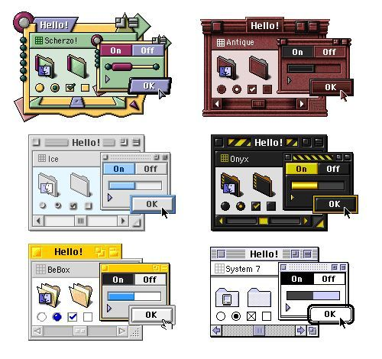

Prompt:
This image is a ready-made version of the system we talked about. It's the Mac OS 8 Appearance Manager: six themes (Scherzo, Antique, Ice, Onyx, BeBox, System 7) all drawing the same widget set. Only the skin changes, never the structure. That's the theme contract.

What the image gives us
1. A fixed parts list. Every theme renders these:
Group | Parts
Window | frame, title bar, title text, zoom/collapse boxes, header strip (the "Scherzo" label row)
Controls | default button (OK, with emphasis ring), On/Off segmented toggle, radio, checkbox
Feedback | progress bar, scrollbar (arrows, track, thumb)
Content | folder/file icons, disclosure triangle, cursor
2. A built-in acceptance test. The "Hello!" sheet is the best idea here: every theme must render the same sample card. If another AI's theme looks right on that card, it's compatible. I'd make that card a required test page in your app.

The six themes fall into three difficulty tiers
Tier | Themes | How they're built | AI-friendly?
1. Tokens + bevels | Ice, BeBox, System 7 | Colors, border widths, 1-px bevels, flat fills; System 7 is pure 1-bit black and white | Very
2. Texture and ornament | Antique, Onyx | Tier 1 plus patterns (hazard stripes, wood-like red) and heavier bevels | Mostly
3. Shape changes | Scherzo | Non-rectangular windows, circle and arrow ornaments, wavy edges, i.e. structure | Needs a shape layer (clip-path/SVG)
So the contract needs three layers: tokens, 9-slice frame/bevel styling, and optional shape/ornament assets. Tier 3 is the only one that touches layout.

How to instruct other AIs for this look
- Give them the sheet and the parts list, not just "make it retro."
- Ask for CSS and SVG, not pixel images. Models draw crisp CSS bevels and SVG shapes far more reliably than sprites.
- Per theme, require: a palette (6 to 8 colors), border and bevel recipe, title bar treatment, control states (normal, pressed, disabled), and one signature detail (Onyx's hazard stripes, BeBox's yellow tab).
- Hard rules: no external requests, no JS, must render the test card.

Next step
Per your workflow, I'll show a mockup before writing any code: the test card rendered in 2 to 3 of these themes with a switcher, plus the parts and token map beside it.
Two quick questions so I aim it right:
- Is the goal a faithful retro Mac look for your apps, or just inspiration for a different style (say, chunky and tactile, but modern)?
- Which themes should the mockup cover first? I'd suggest Ice, Onyx, System 7 (one per difficulty tier) and leave Scherzo for later.

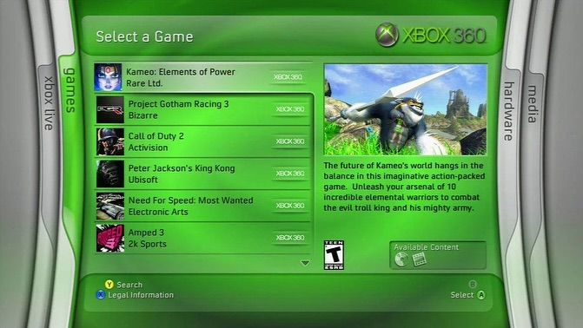

PROMPOT:
This one is a very different beast from the Mac themes. That was a flat, pixel-crisp component kit. This is glossy, layered, curved, and full-screen, like a living-room console menu. Here is what defines it in your screenshot:
- Blades: the curved side panels with vertical rotated labels (xbox live, games, hardware, media). The active blade sits in the center and the others fold away at the edges.
- Glossy green glass: a bright-to-dark green gradient, soft inner glows, and a light sheen across the top of each panel.
- Big rounded containers: a title header, a list panel, and a preview panel, all with generous corner radii.
- List selection: the highlighted row is brighter and paler, and the rest are darker green.
- Footer button hints: small circular button icons with labels like Search and Select.
- Soft vignette background: light in the center, darker toward the edges.

What to tell the model
Attach the image, then paste:
Build a themeable console-style menu UI as a single HTML file
(HTML + CSS + minimal JS, no external images).

Reference: the attached image, a glossy "blades" dashboard
from the mid-2000s.

Layout:
- Full-screen 16:9 stage.
- A large center panel with a header bar (title on the left,
a small logo placeholder on the right).
- Inside it: a vertical list of selectable rows (thumbnail,
title, subtitle, small tag on the right) and a preview
panel with a large image area, description text, and a
small "available content" box.
- On the left and right edges: curved "blade" panels with
vertical rotated labels. The active blade is the center
panel. Clicking a blade label switches panels with a
slide-and-fold animation.
- A footer with controller-style hints (circle icons with
labels such as Search, Select, Back).

Visual style:
- Glossy glass: layered gradients, a soft highlight band
across the top third of each panel, subtle inner glow,
and a faint reflection at the bottom edge.
- Large corner radii, thin light borders, soft drop shadows
that are allowed here.
- Selected row: lighter and brighter with a soft glow.
Other rows: darker with low contrast.
- Background: radial gradient, bright center to dark edges.
- Clean humanist sans-serif font with a system fallback.

Theming:
- All colors in CSS variables.
- Provide 4 color themes: Green (as in the reference),
Blue, Orange, and Dark Aero (black glass with cyan glow).
Switch with a settings option.

Interaction:
- Keyboard: arrow keys move the selection, Enter selects,
Left/Right switch blades, Esc goes back.
- Smooth animations, 200-350ms, ease-out.

Rules:
- Use placeholder content: made-up game titles, colored
rectangles as thumbnails. Do NOT use real game names,
console logos, brand marks, or rating badges.
- Do not use flat design, neon outlines, or modern
frosted-glass blur. The look is gradient-based glossiness.

What to add for better results
- Name the era: "2005-2008 glossy console UI", "Frutiger Aero / Dark Aero", so the model doesn't drift into modern glassmorphism.
- Describe the blade effect precisely: the model may skip it otherwise. Say that the side panels are curved with rotated text and that the active one expands to fill the center.
- Ask for sound as optional: soft whoosh and click sounds make it feel like the original, but they are not required.
- Build in two passes: first the static layout with the glossy styling, then the animations and themes.
If the first result looks too flat, add: "More gradient depth, a stronger highlight band at the top of each panel, and a visible reflection at the bottom."
I can add both prompts (the Mac theme kit and this one) to your doc as a "Build prompts" section, with a short note on which style each prompt suits. Want me to?

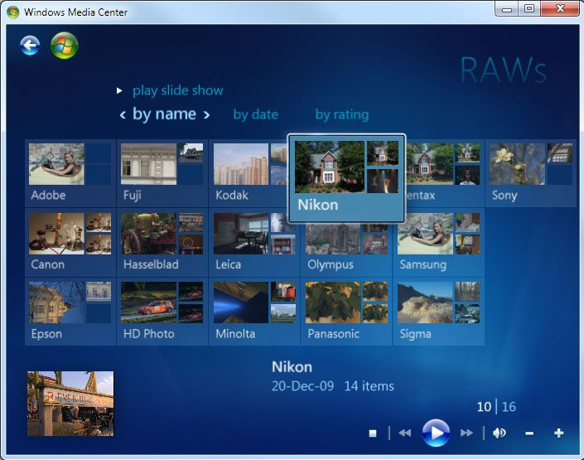

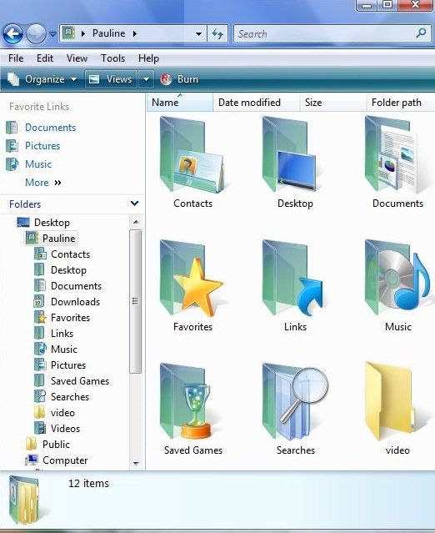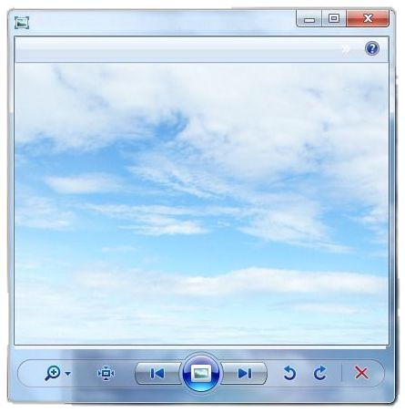

These three are all from the Vista/Windows 7 Aero family, but they show three different moods. That makes them a good basis for a themed kit.
Screenshot | Mood | What defines it
Photo viewer | Light, airy, "Frutiger Aero" | A cloud-sky photo behind the window, translucent glass edges, a rounded toolbar pill with glossy circular buttons, and a big glowing center orb
File explorer | Clean and bright | White content area, blue gradient title and command bars, soft rounded back and forward buttons, and translucent teal-green folder icons with a glassy sheen
Media Center | Dark, immersive, "10-foot UI" | A deep blue radial gradient, soft translucent tiles in a grid, a highlighted tile that pops forward, and light thin type
What they share is the recipe: gradient fills, a highlight band on top, soft glows, rounded shapes, and glass-like transparency over a soft background.

What to tell the model
Build a themeable "Aero-era" UI kit as a single HTML file
(HTML + CSS + minimal JS, no external images).

Reference: the three attached screenshots, which show one design
language in three moods:
1. Light mode: a window over a sky photo with a glass frame,
a rounded toolbar pill, and glossy round buttons with a
large glowing center button
2. File-browser mode: white content area, blue gradient
title/command bars, translucent teal folder icons
3. Immersive mode: dark blue radial background, a grid of
translucent tiles, one highlighted tile that scales up,
light thin typography, a bottom transport bar

Build:
- A window component with a glass frame, title bar, and
min/max/close buttons (close is red on hover).
- A toolbar pill with 5-6 round glossy buttons and one larger
glowing center button (pressed and hover states).
- A file-browser view: left navigation tree, a command bar
with a gradient, and a grid of folder icons made from CSS
or inline SVG (translucent, with a highlight band).
- An immersive grid view: 4x3 tiles with a gradient overlay,
a selected tile that scales 1.08 with a bright border and
glow, and a bottom transport bar with a glowing play button.
- A mode switcher (Light, Explorer, Immersive) at the top.

Visual rules:
- Layered gradients: lighter at top, darker at bottom, plus a
semi-transparent highlight band over the top half of buttons
and panels.
- Glass edges: 1px light inner border, 1px dark outer border,
soft outer shadow. Blur is allowed only on window frames.
- Rounded corners 6-8px on windows, full pills on toolbars,
full circles on the glossy buttons.
- Colors in CSS variables: sky blue and white for Light,
teal and blue for Explorer, deep navy and cyan for Immersive.
- Font: a humanist sans (Segoe-like) with a system fallback.
Immersive mode uses light-weight, larger type.
- Keyboard: arrows move the tile selection, Enter opens.

Content and rules:
- Use only original placeholder content and CSS-drawn images.
No logos, flags, brand names, or real photos.
- Do NOT use flat design, neon outlines, or modern frosted blur
outside window frames. Keep it glossy and gradient-based.

Things to add for a better result
- Name the era and mood: "2007-2010, Frutiger Aero, optimistic, sky and nature." This stops it from drifting toward modern glassmorphism.
- Be explicit about the glossy button: "a circle with a light top half, a darker bottom half, a thin white rim, and a soft outer glow." Models often miss the two-tone effect.
- Ask for a sky background in CSS: radial gradients and a few blurred ellipses make a convincing cloud sky without any images.
- Build the light mode first, check that the gloss reads correctly, then add the other two. The Immersive mode is the easiest to get wrong, so it's best last.

Putting all three images together
You now have three reference sets: the Mac theme kit (flat, pixel-crisp), the Xbox-style blades (green glossy console), and this Aero set (airy and glossy). They could share one component library with three theme families, or stay as separate prompts. I'd keep them separate at first, since mixing them early gets muddy.
I can add all three prompts to your doc as a "Build prompts" section, with a note on which style each one suits. Want me to?

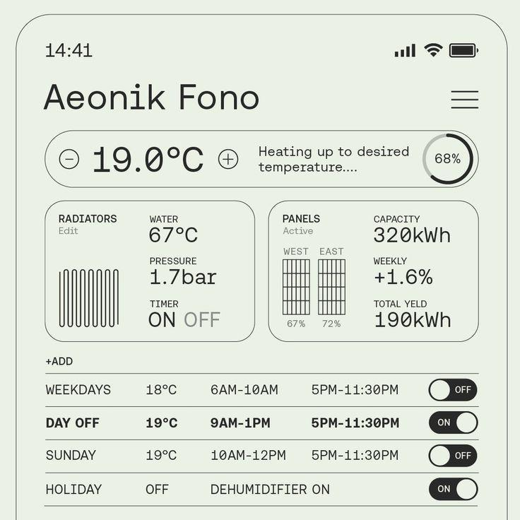

PROMPT:

This one is the opposite of your last three. Where those were glossy, layered, and glassy, this is flat, quiet, and technical: a pale sage background, hairline outlines, and everything carried by typography.

What defines it
- Palette: a single pale green-gray ground with near-black ink. There are no gradients, no shadows, and no accent color.
- Line work: every container is a 1px outline with large rounded corners, and the icons (radiator, solar panels) are drawn in the same thin line.
- Type: a monospace-flavored grotesk, with big numerals (19.0°C, 320kWh) as the visual anchors and small uppercase labels above each value.
- Structure: a pill-shaped control bar, two data cards in a grid, then a ruled table of schedule rows with toggles.
- States: the active row is bold, and the toggles are simple black pills. "ON" is bold, and "OFF" is grayed out.
- Feeling: an engineered instrument panel, close to the "Technical Mono / code brutalism" and "data-dense utilitarian" styles in your doc.
The title "Aeonik Fono" looks like the name of the typeface being shown, so this is probably a type specimen rendered as a UI. That means the font is doing most of the work. Free alternatives with a similar feel are Space Mono, DM Mono, JetBrains Mono, IBM Plex Mono, and Space Grotesk.

What to tell the model
Build a mobile dashboard UI as a single HTML file
(HTML + CSS + minimal JS, no external images).

Reference: the attached screenshot. A calm, flat, technical
smart-home panel with a type-first look.

Layout (phone frame, about 390px wide):
- Status bar row (time, signal, wifi, battery as line icons)
- Large title and a hamburger icon (3 thin lines)
- A control pill: minus button, big temperature value, plus
button, a short status sentence, and a circular progress ring
with a percentage
- Two side-by-side data cards, each with a small title, a
"Edit"/"Active" subtitle, a line-art illustration (radiator
coils / solar panel grids, drawn in inline SVG) and 3 stat
blocks (small uppercase label, large value)
- A "+ADD" link, then a ruled table of schedule rows (name,
temperature, two time ranges, a toggle). One row is bold as
the active row. Rows are separated by 1px lines.

Visual rules:
- Background: pale sage (#e8efe3). Ink: near-black (#1a1a1a).
Second tone only for inactive text (about 45% opacity).
- No gradients, no shadows, no fills except the toggle pills.
- Borders: 1px solid ink. Radius: 24px on cards and the control
pill, full pill on toggles. The phone frame is a thin outline.
- Icons and illustrations: 1px stroke line art in inline SVG.
- Type: one monospace-flavored grotesk, with fallbacks
(Space Mono, DM Mono, then monospace). Three sizes only:
small uppercase labels (11px), body (15px), numerals
(clamp 28-44px). Tabular numerals on.
- Uppercase labels with slight letter spacing; sentence case
for statuses.

Interaction:
- The +/- buttons change the temperature in 0.5 steps and
update the progress ring.
- Toggles switch ON/OFF with a quick slide. The active row
turns bold when its toggle is ON.
- Everything keyboard-focusable with a visible 2px outline.

Theming:
- Colors in CSS variables. Provide 4 themes: Sage (as in the
reference), Paper (warm off-white), Ink (dark: near-black
background, pale ink), and Signal (pale background, one
orange accent for active states).

Rules:
- Use made-up values and labels. No brand names or logos.
- Do NOT add icons from a library, glassy effects, or
decorative color. Keep it quiet and precise.

Things worth adding
- Name the style: "Swiss, instrument-panel, type-first, hairline UI." This steers it away from generic dashboards.
- Be strict about contrast: say that hierarchy comes only from size and weight, not color. Models love adding an accent color.
- Ask for alignment: "Everything snaps to an 8px grid, and values align to a shared baseline."
- Build one screen first, check the type and spacing, then add the themes. With flat styles, the spacing is what makes it look right.

Where it fits in your collection
You now have four directions: flat pixel kit (Mac themes), glossy console (Xbox blades), airy glass (Aero), and this minimal technical one. They span a very wide range, which is good for your goal of seeing variety.
I can add all four prompts to your doc as a "Build prompts" section, with a note on which style each one suits. Want me to?
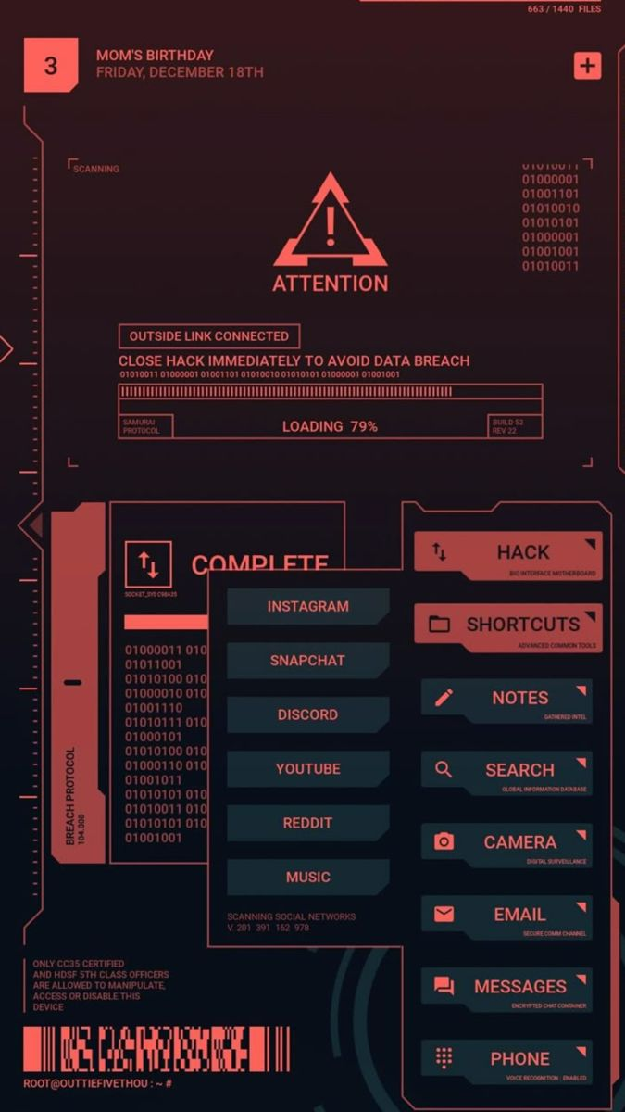
PROMPT:
This one is the opposite of the Mac OS 8 sheet. That one was a skin on fixed shapes. This is a shape language: the look comes from clipped corners, brackets, and decorative data, so a pure token theme won't reproduce it. It's a Cyberpunk 2077 / Samurai-style HUD, built as a phone home screen.

Breakdown
Layer | What's in the image
Tokens | One accent (coral red ≈ #F2685F), near-black plum background, dark teal-slate fill for secondary panels, two-tone text (bright coral and dimmed coral), uppercase condensed sans-serif plus a tiny mono for captions
Shape | Chamfered corners (45° cuts on one or two corners per panel), corner brackets ⌜ ⌟, ruler ticks along the edges, a notched border with a diamond marker
Components | Primary button (solid coral, icon left, label right, tiny subtitle underneath), secondary button (teal fill, coral label, corner flag triangle), list row (flat teal slab with a clipped edge), progress bar (segmented ticks inside a bracket frame), alert block (triangle icon plus boxed status tag), badge (number square), vertical side tab, barcode footer
Ornament | Binary text columns, "SCANNING" micro-labels, build/rev stamps, a terminal prompt line (ROOT@...:~#), a faint circular HUD arc in the background

What makes it work
- Every panel has a tiny caption. Each button carries a second line ("BIO INTERFACE MOTHERBOARD"). That is most of the sci-fi feel for almost no cost.
- Hierarchy comes from fill, not color. There is only one hue. Solid coral means primary, dark teal means secondary, outline-only means container.
- Chamfers, never radii. No rounded corners anywhere, so the shape language is consistent.
- Decorative data is part of the theme. The binary and barcode are filler, so they should be a swappable "ornament" layer rather than hardcoded.

How it fits your contract
The Mac sheet needed three layers. This one needs a fourth:
Layer | Mac OS 8 sheet | This HUD
Tokens | Colors, bevels | Colors, type, one accent
Parts | Window, button, toggle | Panel, button (primary/secondary), list row, progress, alert, badge
Shape | Only Scherzo | Core to the look: needs clip-path chamfer values as tokens (--cut: 12px)
Ornament | Icons | Core to the look: corner brackets, ticks, captions, binary filler
So the contract should treat shape and ornament as first-class, safe, CSS/SVG-only slots: --cut-tl, --cut-br, --bracket-style, --caption-visible, and an optional ornament slot (SVG strings, sanitized).

The surprising part
Your two references sit at opposite ends of the same spectrum. Mac OS 8 is skeuomorphic and material. This is graphic and diagrammatic. If one contract can express both, it will be able to express nearly anything. That makes them a good pair for testing the contract.

Instructions for other AIs on this one
- Tell them it is one hue plus two neutrals. Models tend to add accent colors unprompted.
- Require chamfers via clip-path: polygon() driven by tokens, never border-radius.
- Require a caption line on every button and panel, and make it optional per component.
- Ask for ornament as separate SVG snippets, so the theme still works if ornament is turned off.
- Provide the same test card idea: a sample screen with one alert, one progress bar, one primary and one secondary button, and a three-row list.

Next step
I'll mock up one test card rendered in 3 themes: Mac OS 8 "Ice" (or System 7), Onyx, and this HUD, switchable, with the token/shape/ornament map beside it. That tests whether one contract can really hold both extremes.
Any other inspirations to add first, or should I go ahead with that mockup? Also, is the HUD look meant for phone-sized apps like the screenshot, or desktop too?
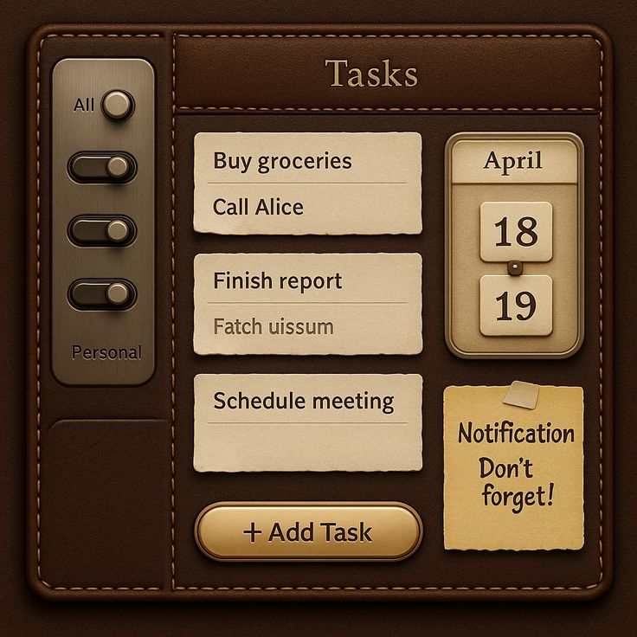
PROMPT:

This one adds a third axis: material. The Mac sheet was bevels on fixed shapes, the HUD was a shape language, and this is a physical-object language. Everything looks like leather, paper, brass, or a sticky note. It's an app-sized "Tasks" screen with a sidebar, a header, a list, a calendar widget, a note, and a CTA.

Breakdown
Layer | What's in the image
Tokens | Chocolate brown base (#3A2418-ish), cream paper (#E8DCC0), brass/gold accent, muted tan for secondary text; a serif for the title (small caps feel), a humanist sans for list items, a handwritten font for the sticky note
Material | Leather grain on the frame, stitched seams (dashed inset border in orange thread), brushed metal on the sidebar, paper with torn/deckled edges, a glossy brass pill button
Depth | Debossed (pressed-in) panels, embossed header strap, soft drop shadows under paper, inset shadows on toggles
Components | Header strap, sidebar with metal toggle switches, list cards (paper), flip-style date widget, sticky note with tape, brass pill button
Ornament | Stitching, tape, the pivot pin on the calendar, grain texture

What makes it work
- Every surface has a material and a depth direction. Paper sits on the leather and toggles sit in the metal. Decide raised vs. pressed per part, and the whole screen stays coherent.
- Stitching is a cheap, high-impact detail. It is just a dashed border inset a few pixels from the edge.
- Contrast comes from material, not color. Dark leather behind light paper does the job that coral-on-plum did in the HUD.
- The one playful part is the sticky note. Slightly rotated, a different font, and taped on. A theme needs one such "human" element to avoid feeling like a template.

Heads-up about this image
It looks like an AI-generated concept render: the filler text "Fatch uissum" is garbled, and the toggle labels don't make functional sense. Take the look from it (material, depth, palette), not the layout logic or copy. The same applies when other AIs generate themes: they'll copy visual quirks unless told which details to ignore.

Updated contract
Your three references now cover three different theme types, so the contract has five channels:
Channel | Mac OS 8 | HUD | Leather
Tokens (color, type) | ✓ | ✓ | ✓
Parts (same components) | ✓ | ✓ | ✓
Shape (clip-path, radius) | minor | core | torn edges, pill
Material (texture, bevel, shadow) | core | minimal | core
Ornament (SVG decorations) | icons | core | stitching, tape, pin
Material should be expressed safely as:
- Layered shadows (--shadow-raised, --shadow-pressed)
- Procedural textures via inline SVG feTurbulence (grain, paper), with no external images
- Border recipes (stitch: color, dash, inset)
- Edge treatments (torn edge as an SVG mask preset)

Instructions for other AIs on this one
- Name the material for every part ("header = leather strap, embossed; list item = paper, torn edge, soft shadow").
- Specify raised or pressed for each part.
- Ask for textures as inline SVG filters or CSS gradients, never image URLs.
- Limit the palette: 2 browns, 2 creams, 1 brass.
- Tell them to ignore the placeholder text in the reference.

Where we are
You now have three poles:
- Skeuomorphic UI chrome (Mac OS 8)
- Diagrammatic HUD (cyberpunk)
- Physical objects (leather and paper)
If one contract handles all three, it handles nearly anything. I'd now build the mockup: one test card (alert, progress, primary and secondary button, a three-row list, a toggle) rendered in System 7, HUD, and Leather, switchable, with the five-channel token map beside it.
Want me to go ahead with that, or do you have more inspirations first? And is this for phone-sized, desktop, or both? That changes how I lay out the test card.
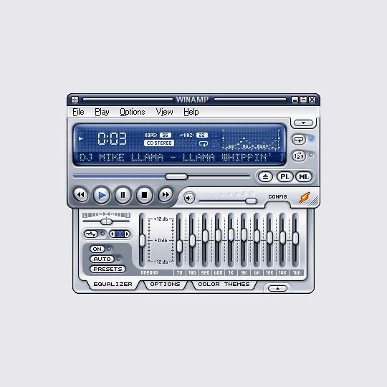
PROMPT:
This one is the historical precedent for exactly what you're building: Winamp skins were themes made by thousands of different people and loaded into one app. It's also a dense instrument panel (small controls, lots of state), a fourth style type alongside your other three.

Breakdown
Layer | What's in the image
Tokens | Steel-blue and silver palette, one glowing LCD blue (#5B8CFF-ish) on a dark navy field, white/light-gray text; pixel-style type for the readout, tiny caps for labels
Material | Brushed-metal silver, glossy rounded buttons, recessed LCD with an inner glow, beveled sliders
Shape | Rounded rectangles, a tab strip with angled "folder" tabs, a title bar with micro-buttons
New parts | LCD readout (time, scrolling marquee, bitrate), transport buttons (round, icon only), horizontal and vertical sliders, tab strip (Equalizer / Options / Color Themes), menu bar, toggle pills (ON / AUTO / PRESETS), spectrum visualizer
Ornament | Slider tick marks, dB scale labels, the flame icon, the grip dots

What matters most here
- "Color Themes" is a tab inside the skin. Winamp separated skin (structure and material) from color theme (palette variant). Your contract needs the same two levels: a theme package can ship several palettes without redrawing anything.
- The LCD readout is a part of its own. It has a glow, a scrolling marquee, and a monospace face. Any app could use it (calculator display, database row count, dashboard KPI), so it belongs in the generic parts list.
- Sliders are the hard part. Track, thumb, fill, and ticks each need a style. A model skipping any of them will break the look, so list them explicitly.
- Density is a token. Small controls and tight spacing are part of the feel. Add --density or a spacing scale so a theme can be compact (Winamp) or airy (leather).

The lesson from how Winamp did it
Classic skins were bitmap sprites at fixed pixel coordinates. That's why they never scaled and why every skin had to match one exact layout. Don't copy that. Your system should use CSS and SVG against named parts, so a theme works at any size and in any app. Winamp's later "modern" skins moved toward XML manifests plus assets, which is roughly the manifest idea from Step 1.

Updated parts list (app-agnostic)
Group | Parts
Containers | window/frame, panel, header, tab strip, menu bar
Actions | primary button, secondary button, icon/transport button, toggle pill
Inputs | slider (H/V), checkbox, radio, switch, text field
Display | readout (LCD), list row, badge, progress bar, visualizer bars
Feedback | alert, notification note
That covers calculator (readout, buttons), database (list rows, tab strip, text field), dashboard (readout, progress, panels), and media player (all of it).

Where the four references land
 | Mac OS 8 | HUD | Leather | Winamp
Core idea | Bevel skin | Shape language | Physical material | Instrument panel
Biggest demand on the contract | Fixed parts list | Chamfer and ornament tokens | Texture and depth | Readout, sliders, density, palette variants
I think this is enough range. Two choices before the mockup, since they change how I build it:
- Test card contents: should it be generic (alert, progress, buttons, list, toggle, readout, slider) or tied to a real app you're building?
- Which themes in the mockup? I'd suggest System 7, HUD, Leather, Winamp-blue, switchable, with the five-channel token map beside it.
Say "go" and I'll build the mockup. No code for the actual loader until you approve it.

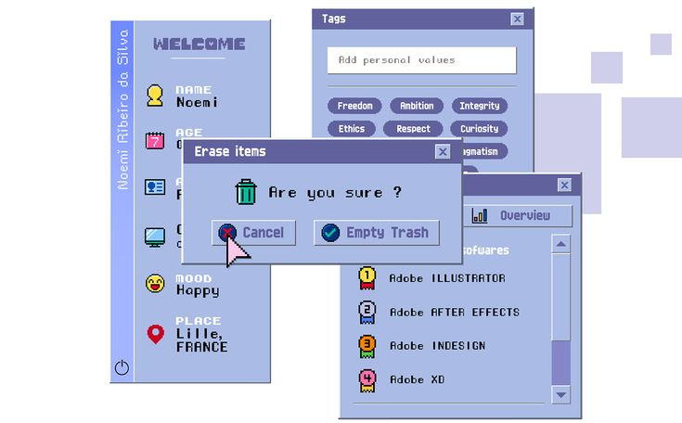
PPP:

This is a pixel-art, Windows 95/98-era "vaporwave" UI, and it's the simplest of your five to implement while still being the most distinctive. One periwinkle hue, a pixel font, and hard 1-px edges do almost all the work.

Breakdown
Layer | What's in the image
Tokens | One hue family: periwinkle #A9B5E6-ish panels, deeper indigo #5C5F9E title bars and chips, near-white fields, dark navy text; a pixel/bitmap font for everything
Material | None. Flat fills with a hard 1-px dark outline and a hard offset shadow (no blur)
Shape | Square corners, pill chips for tags, rectangular dialogs with a title bar and an X box
Components | Window with title bar and close box, modal dialog (icon, question, two buttons), tag chip, text field, vertical scrollbar with arrows, list row with a numbered medal icon, sidebar profile list (icon, label, value), tab-style button ("Overview"), vertical text label
Ornament | Pixel icons (trash, calendar, ID card, pin), a pixel cursor, floating translucent squares in the background, a power icon

What makes it work
- Everything snaps to a pixel grid. Icons, borders, and the font all appear to be on the same ~2x scale. The theme breaks the moment something is anti-aliased or has a soft shadow.
- Hard offset shadows are the depth model. A solid dark rectangle shifted 3 to 4px down-right gives layering with zero blur.
- Small icon-plus-label rows carry the content. The sidebar (icon, tiny caps label, bold value) is a reusable "property row" part.
- Overlapping windows are the composition. The look needs z-stacked, slightly offset panels, which is a layout behavior, not just styling.
- The pixel font does 50% of the work. Without it this is just a blue UI.

What it adds to the contract
Almost nothing structurally, which is the point. It slots into the existing channels, but two tokens must become explicit that your earlier themes didn't force:
New or sharpened token | Why
--font-pixel plus --font-smoothing: none / image-rendering: pixelated | Crisp bitmap rendering, or the look dies
--shadow-hard: 4px 4px 0 <color> | No-blur shadow recipe (separate from the soft shadows in Leather)
--pixel-scale | Snaps borders, icons, and spacing to a grid (2x, 3x)
Icon set as a swappable slot | Pixel icons vs. line icons vs. skeuomorphic icons must be replaceable per theme
The icon slot is the lesson from this one: icons are part of the theme. Your five references all use different icon styles, so a theme should be able to supply its own icon set (SVG sprite) instead of the app hardcoding one.

Where the five references land
 | Mac OS 8 | HUD | Leather | Winamp | Pixel Retro
Style type | Bevel skin | Shape language | Physical material | Instrument panel | Flat pixel grid
What it stresses | Parts list | Chamfer + ornament | Texture + depth | Readout, sliders, density | Pixel font, hard shadow, icon set
Difficulty for AI | Low | Medium | High (texture) | High (sliders) | Lowest

Updated parts list
New or confirmed from this one: modal dialog, tag/chip, property row (icon, label, value), scrollbar, rank/medal list row. Added to the earlier list, that covers a profile page, a settings screen, and a file manager on top of calculator, database, dashboard, and media player.

Ready for the mockup
Six references is plenty. My plan for the mockup is one generic test card, containing:
- Window with title bar
- Alert / modal dialog
- Primary and secondary button
- Toggle and slider
- Readout (LCD-style)
- Tag chips
- Three-row list with icons
- Progress bar
rendered in Mac OS 8 (System 7), HUD, Leather, Winamp-blue, and Pixel Retro, with a switcher and the six-channel token map (tokens, parts, shape, material, ornament, icons) beside it.
Say "go" to start the mockup, or tell me if you want to swap any theme out. One last question that affects the layout: phone-sized, desktop, or both?

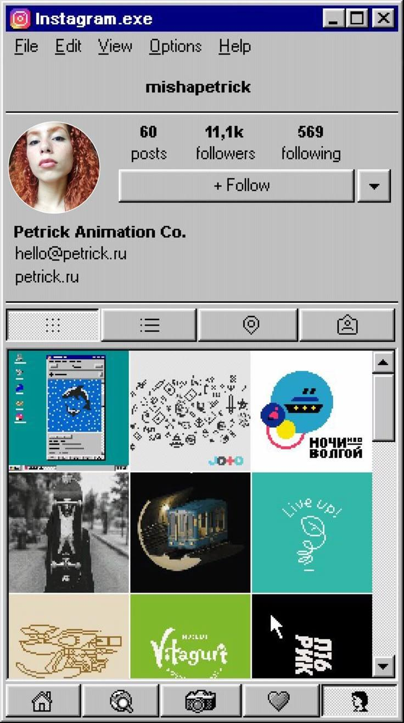
Added as its own theme, #6: Windows 98 "Gray Bevel". It stays separate from Pixel Retro (flat periwinkle, hard shadows) and Mac OS 8 (the Mac bevel family).

Breakdown
Layer | What's in the image
Tokens | Silver-gray #C0C0C0 surfaces, navy #000080 title bar, black text, white and dark-gray bevel colors; a plain system sans (MS Sans Serif / Tahoma feel), bold only for names and numbers
Material | The classic 2-px raised bevel (white top-left, dark gray bottom-right). Pressed or selected flips it to inset
Shape | Square corners everywhere. The one exception is the round avatar, which stays round because it's content, not chrome
Components | Title bar with min/max/close boxes, menu bar, etched divider lines, stat block (number over label), split button (+ Follow with a dropdown arrow), icon tab strip, thumbnail grid with scrollbar, bottom icon nav bar
Ornament | Small pixel icons, the dither pattern (checkerboard) marking the active tab, black 1-px grid lines

What makes it work
- The bevel direction carries all the state. Raised is idle, inset is pressed, and a dithered fill means selected. Hover and active need no extra colors.
- Etched dividers (a dark line with a white line beneath) structure the page without any cards.
- The restraint is the style. One gray, one navy, and black text. Anything extra breaks it.
- Content stays untouched. The photos in the grid are full color and aren't themed. A theme styles the chrome only, so the contract should say so.

What this one proves
This is a real app reskinned: the same Instagram profile screen, wearing a different theme. That is your goal ("regardless of what it does"). It also makes this one the best candidate for a real-app test card instead of a generic one.
It also adds a few things to the parts list:
New part | Notes
Stat block | Number over label, repeated 3 times
Split button | Main action plus a dropdown arrow
Bottom nav bar | Icon-only, with one active (inset and dithered)
Media grid + scrollbar | A content area the theme frames but doesn't recolor
Avatar | A round exception to a square theme: a --avatar-shape token
New tokens: --bevel-light, --bevel-dark, --bevel-width (so a theme can go 1-px, like System 7, or 2-px, like this one), and --dither-pattern for selected states.

Where it sits
 | Mac OS 8 | HUD | Leather | Winamp | Pixel Retro | Win98
Style type | Bevel skin | Shape language | Physical material | Instrument panel | Flat pixel grid | Strict bevel + state-by-bevel
Difficulty for AI | Low | Medium | High | High | Lowest | Low
Six themes is plenty. Two choices will shape the mockup, and your answers settle them:
- Test card: generic (alert, progress, buttons, list, toggle, readout, slider) or a profile-style screen like this one, which exercises more parts (stats, grid, nav bar)?
- Layout: this reference is phone-proportioned inside a desktop-style window, so I'd build the card at phone width and show it inside a themed window frame. That covers both.
Say "go" with your answers and I'll start the mockup. No loader code until you approve it.

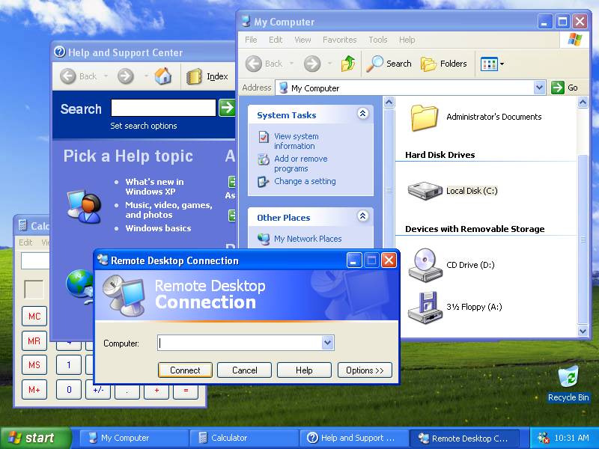

Added as theme #7: Windows XP "Luna". It stays separate from Win98: same lineage, but a completely different material language.

Breakdown
Layer | What's in the image
Tokens | Luna blue #0A58D8-ish title bars, cream-beige #ECE9D8 window bodies, green Start/Go accent, orange accent line under dialog headers, Tahoma at 8 to 11px
Material | Gradients, not bevels. Glossy vertical gradients on title bars and buttons, soft inner highlights, light drop shadows under windows
Shape | Rounded top corners on windows (about 8px), small rounded buttons (about 3px), square content areas. A rounded-top, square-bottom window is the signature silhouette
Components | Title bar with min/max/close (the close button is red and stands out), menu bar, toolbar with icon and label buttons, address bar with a dropdown and green Go, task pane with collapsible groups, banner header ("Remote Desktop Connection"), dialog button row with a default-button blue ring, taskbar with green Start button and window tabs, tray clock
Ornament | The wallpaper, the banner artwork, glossy icons, chevron collapse buttons

What makes it work
- The title bar gradient is 70% of the look. Blue, lighter at the top, with a subtle highlight band and a rounded top edge.
- The collapsible task pane (System Tasks, Other Places) is the signature layout part. It's a styled panel with a header, a chevron, and a link list.
- The default button gets a blue inner ring. State is shown by ring and gradient, which is different from Win98's bevel flip.
- Window chrome and body are different colors. Blue frame, beige body, white content area. Three layers.
- A dialog banner ties the window to its purpose. A gradient strip with title text and a decorative icon.

What it adds to the contract
New or sharpened | Why
--gradient-title, --gradient-button | Gradient recipes as tokens, not just flat colors
--radius-window-top vs --radius-control | Separate radii for frame and controls
--focus-ring / default-button ring | State styling beyond bevel or shadow
Collapsible group part | Task pane group: header, chevron, body
Banner header part | Gradient strip with title and art slot
Taskbar / window tab parts | Only needed for shell-like apps, so mark as optional

Watch out for
This reference includes a photographic wallpaper (Bliss). That's content, not theme. It's also Microsoft's imagery, so a theme should supply its own background token (gradient or neutral) rather than the real asset. Likewise, in all of these references, use the style and not logos, brand icons, or copyrighted artwork. The same goes for the Instagram and Winamp references: reproduce the look, not the marks.

Where the seven land
 | Style type | Difficulty for AI
Mac OS 8 | Bevel skin | Low
HUD | Shape language | Medium
Leather | Physical material | High
Winamp | Instrument panel | High
Pixel Retro | Flat pixel grid | Lowest
Win98 | Strict bevel, state by bevel | Low
XP Luna | Gradient gloss + rounded frame | Medium (gradients must be tuned)
Notice that four of your seven are desktop-OS chrome from different eras. That's a strong hint that your contract should include a window chrome layer (title bar, controls, frame) that any theme can restyle or replace.

Time to build
Seven is plenty, and more will just blur the contract. I still need two answers before building the mockup:
- Test card: generic, or a profile-style screen with stats, grid, and a nav bar?
- Which themes in the first mockup? Seven at once is heavy. I'd suggest System 7, Win98, XP, HUD, Leather, then add Winamp and Pixel Retro in round two. Or all seven if you prefer.
Say "go" with your picks.

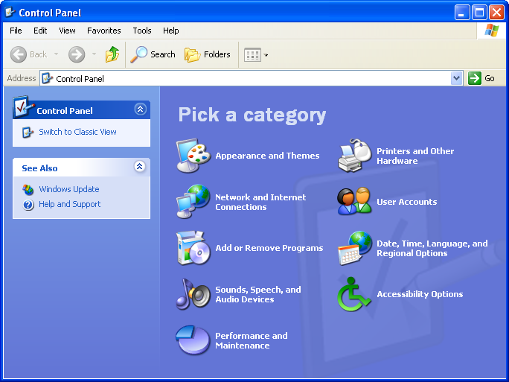

This one isn't a new theme. It's the Windows XP Luna category view, so I'm attaching it to theme xp (Ref 7) as a second reference instead of making an eleventh theme. Nothing here conflicts with the earlier XP breakdown. It adds a different kind of content area.

What it adds to xp
Layer | What's in the image
Tokens | Content area is a periwinkle-blue (#6375D6-ish) instead of white. Heading text is pale blue-white, link labels are white. The task pane body is light blue (#D6DFF7-ish) with dark-blue links.
Material | The task pane's top group has a dark blue gradient header with white bold text and a round chevron button. The second group (See Also) has a light header with dark-blue text. Same part, two variants.
Ornament | A large, faint watermark shape (oversized pale icon) bleeding off the bottom-right of the content area
Typography | "Pick a category" is a large bold display heading in a lighter tint of the background, with no outline

New parts and variants
Addition | Notes
categorytile | Large icon on the left, wrapped bold label on the right, white text, in a two-column grid. Needs idle, hover (underlined or highlighted label), and focus states.
tilegrid | The two-column layout container for tiles. Rows align to the icon height.
group variants | group--featured (dark gradient header, white text) and group default (light header, dark text). The collapse chevron is a round button.
heading-display | Large heading style, separate from titlebar and banner.
watermark slot | Ornament slot for one big decorative shape in a content area.
--content-bg | Content background token, so a theme can use white (My Computer view) or colored (category view).

Rules for the agent on this reference
- Make all tiles from original icons. No Windows icons, no Windows Update icon, no copy of the watermark art.
- The category names ("Appearance and Themes" and so on) are stand-in text. Use neutral labels.
- This view should be the same xp theme switching content styles, not a separate theme file.
- Test page A should include a tile grid inside a themed content area to verify it.

Why it matters for the contract
It proves a theme must control the content area background, not just the chrome. That contradicts the earlier rule "content is not themed," so I'd refine it: user media is never recolored (photos, album art, thumbnails), but the surface the content sits on is part of the theme. I'll put that wording in the brief.
I'm holding the changes until you're done and will fold all of them into theme-system-brief.md in one pass, so you don't get five versions. Send the next one.

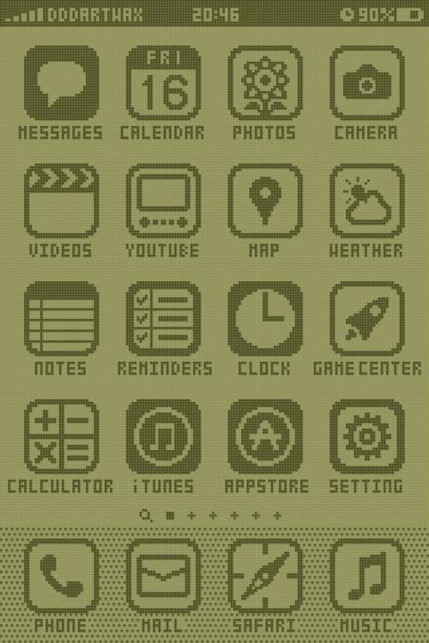

PPR:
This one is a new theme: #11, a Game Boy-style monochrome LCD, shown as a phone home screen. It stays separate from Pixel Retro (periwinkle, window chrome, hard shadows). This one has no windows at all. It's a single-color display with an icon grid.

Breakdown
Layer | What's in the image
Tokens | Two colors only: pale olive-green background (#9BA85A-ish) and dark olive ink (#4A5320-ish). Every element is one of the two, plus a dithered mix of them. Pixel font in uppercase for every label.
Material | Flat. The only depth device is a fine pixel-grid texture over everything (visible LCD cells). The dock uses a dither pattern to separate itself from the page.
Shape | Icons sit in rounded-square tiles with thick ink outlines (about 8px radius at this scale). Pixel-stepped corners, never smooth curves.
Components | Status bar (signal bars, carrier, clock, battery), icon tile plus label, page indicator (search glyph, square, plus signs), dock with a dithered background
Ornament | LCD cell grid overlay, dithered dock, pixel status glyphs

What makes it work
- The palette is the constraint. Two ink values and nothing else. Any third color breaks it, so the token set should be --ink and --paper and the agent shouldn't add any others.
- Icons carry the theme. Each icon is drawn on a coarse grid in one ink color, with fills used for emphasis (Messages is solid, Calendar is outlined). A consistent pixel grid across all icons matters more than detail.
- The cell-grid overlay is cheap and powerful. A repeating linear-gradient mask at --pixel-scale gives the LCD look without images.
- Selected and pressed states invert. Swap ink and paper, which is how real monochrome UIs work. No extra colors are needed.
- Dither replaces shadow and gradient. Use a checkerboard fill where other themes would use a gradient.

What it adds to the contract
Addition | Notes
--palette-mode: mono | Tells the loader the theme uses --ink and --paper only, so test pages can check that no other colors appear
--ink, --paper, --dither-pattern | --dither-pattern is already in the contract. This theme uses it heavily
--lcd-grid | Overlay token: cell size and opacity. Optional for other themes
inverted state | Selected, pressed, and focus all map to ink and paper swapped
icontile part | Icon in a rounded square with a label below. Used for launcher grids
statusbar variant | Top status strip (signal, clock, battery) for phone-style screens
pageindicator part | Row of small glyphs showing the current page
dock part | Bottom bar of icontiles with its own background treatment
This reference also shows the launcher grid use case. Your earlier references were windows and dialogs, so this widens the contract toward home screens and app launchers.

Rules for the agent on this reference
- Original icons only. The icons in this reference imitate real app icons, so the agent should draw its own generic ones (message bubble, calendar, camera, and so on) and not copy this sheet or reproduce any brand's icons.
- App names are stand-in text. Use neutral labels such as "Messages" or "Calendar."
- Use a pixel font supplied as a system stack or a data-URI font, with image-rendering: pixelated.
- The theme must pass Test page A with only two colors present. I'd add an automated check for it.
- Phone-width is the natural size for this one, so test it at both phone width and desktop width.

Status
Eleven references now cover ten distinct themes, plus a second XP view. I'm still holding all additions (XP category view, the refined "content" rule, and this theme) for one clean update to theme-system-brief.md when you say you're done.
Send the next one.

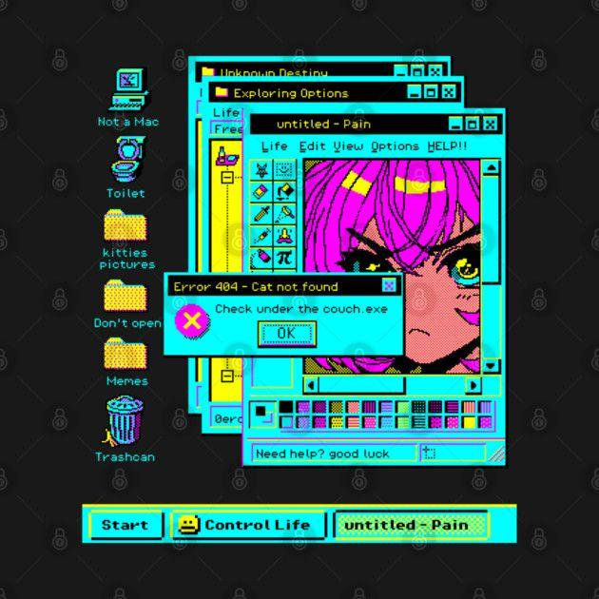
PPR:

This is another new theme: #12, a CGA-style neon desktop. It stays separate from Pixel Retro (soft periwinkle, one hue family) and the Game Boy theme (two colors). This one is loud, high-contrast, and limited to a fixed handful of saturated colors, in a parody-desktop composition.

Breakdown
Layer | What's in the image
Tokens | A CGA-like palette: cyan #00FFFF-ish for window frames and chrome, yellow #FFFF00-ish for panels, magenta #FF00FF-ish for emphasis, black for outlines and the desktop, white for highlights. Nothing outside this set, and no gradients. Pixel font, mixed case.
Material | Flat fills, 1-px black outlines, and dither patterns (checker and halftone) for shading and "disabled" areas. No blur anywhere.
Shape | Square corners. Title bars are solid cyan with a black pixel title and three small square buttons.
Components | Stacked overlapping windows (explorer, paint-style app), menu bar, tool palette (grid of small icon buttons), color swatch palette, scrollbars with arrow boxes, error dialog (icon, message, OK), taskbar with Start button and window tabs, desktop icons with labels, status bar with a text field
Ornament | Dithered icons, a checkered selected-tab fill (the active taskbar item), pixel cursor-style glyphs

What makes it work
- The palette is a hard limit. Four or five fixed colors. The agent must treat this as a closed set, like the Game Boy theme's two inks.
- Dither is the shading system. Where other themes use a gradient or shadow, this one uses a checkerboard or halftone, so --dither-pattern needs more than one preset (checker, halftone, stripes).
- Overlap is the composition. Windows stack with offset, each fully outlined, so depth comes from layering and not shadows.
- Active state = dithered fill. The selected taskbar tab uses a pattern fill and the others are solid.
- Humor is in the copy, not the theme. The jokes (fake error, silly folder names) are content. A theme provides the look, and the app provides the text.

What it adds to the contract
Addition | Notes
--palette-mode: fixed with --palette-colors list | Generalizes the Game Boy mono mode. The test pages check that only listed colors appear in rendered output.
Multiple dither presets (--dither-checker, --dither-halftone, --dither-stripe) | Replaces the single dither token
toolpalette part | Grid of small icon toggle buttons, one selected
swatchpalette part | Grid of color or pattern cells, one selected, with a "current" cell
desktopicon part | Icon above a label, with a selected state. Close relative of icontile from the Game Boy theme, so I'd merge them into icontile with a layout variant
taskbar / taskbar-item | Already optional. This theme needs the active item style

Rules for the agent on this reference
- The anime artwork in the paint window is content, and a theme never draws it. Use a generic placeholder image area (a dithered fill or a stand-in picture slot).
- All icons are original pixel icons, not copies of the ones in the reference. Don't reproduce the specific icon designs or labels such as "Not a Mac."
- Use neutral stand-in text for the joke labels and error text.
- Enforce the palette: any color outside the fixed list is a failure.
- Pixel font, image-rendering: pixelated, and snap to --pixel-scale, the same as Pixel Retro. The palette and dither style are what separate them.

How it differs from nearby themes
 | Pixel Retro | Game Boy LCD | CGA Neon (new)
Palette | Periwinkle family | 2 inks | 4 to 5 fixed saturated colors
Shading | Hard offset shadow | Dither plus cell grid | Dither presets
Composition | Overlapping windows | Icon grid, no windows | Overlapping windows plus taskbar
Vibe | Soft, calm | Quiet, mono | Loud, high-contrast

Status
Twelve references now cover eleven distinct themes plus the second XP view. Still holding all additions (XP category view, the refined content rule, Game Boy LCD, and this theme) for one clean update to theme-system-brief.md. One thing I'd settle in that update: with 11 themes, the phase plan should keep round one at five themes and group the rest by family. Send the next one, or tell me when you're done.

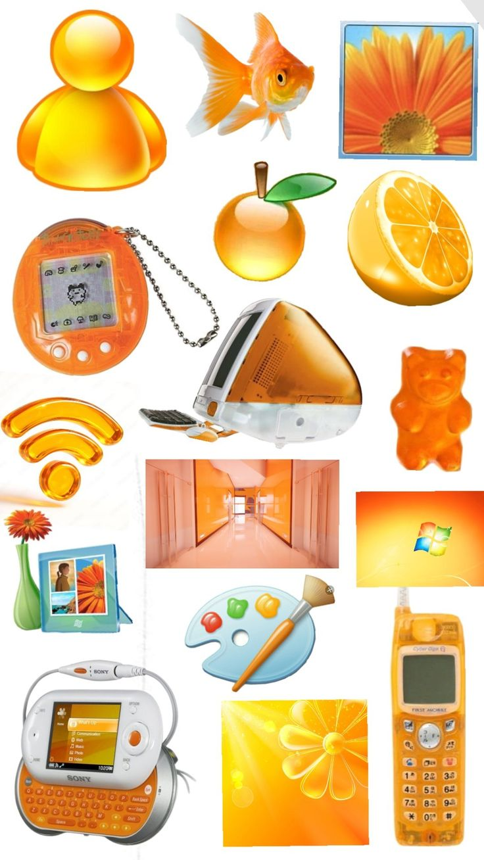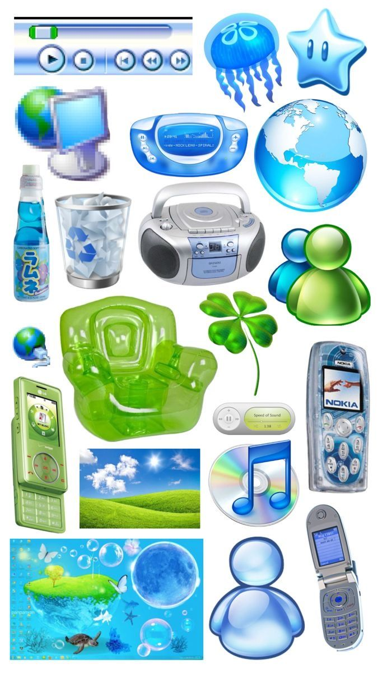
PPR:
These two boards are one new theme, #13, Y2K glossy "gel" (Frutiger Aero), shown as two palettes: orange and blue/green. Both boards share the same material, so they're palettes of one theme, the way Winamp ships Color Themes. They aren't two themes.
Unlike your earlier references, these are mood boards, not UI screenshots. There's no layout to copy. They define the material, palette, and icon style, and the agent should apply them to the standard parts list.

Breakdown
Layer | What's in the boards
Tokens | Palette A "amber": tangerine and honey orange with cream-white. Palette B "aqua": sky and ocean blue plus a lime-green secondary. White or very light backgrounds in both. Humanist sans (Segoe/Frutiger feel, system stack).
Material | Glossy gel and translucent plastic. Saturated gradient body, a bright hard-edged specular highlight across the top half, inner glow, a darker rim, and a soft colored drop shadow. Glass panels are translucent with a blur.
Shape | Very round: orbs, pills, droplets, blobs. Almost no sharp corners.
Components (implied) | Orb button, pill button, glass panel, media transport bar (round glass buttons plus a pill slider with a glass thumb), toggle pill, bubble badge, gel avatar/contact icon
Ornament | Bubbles, lens-flare rays, droplets, sparkles, nature motifs (flower, leaf, grass hill, sky), a reflective floor under objects

What makes it work
- The gloss highlight is the identity. A white-to-transparent gradient over the top ~45% of the element with a curved lower edge. If the highlight is missing, it reads as a flat gradient.
- Colored shadows, not gray. The drop shadow is a darker tint of the object's own hue.
- Translucency is part of the material. Objects look like colored plastic, so panels should show what's behind them via backdrop-filter and partial alpha.
- Restraint in hue. Each palette has one main hue plus (in aqua) a lime-green secondary and white. Don't add purple or pink.
- Icons are glossy objects, not line glyphs. A gel icon set is as essential here as the pixel icon set was for Pixel Retro.

What it adds to the contract
Addition | Notes
--gloss-highlight | Gradient and shape recipe for the specular band
--rim, --glow | Outer edge color and inner glow
--shadow-colored | Shadow tinted by the accent
--glass-blur, --glass-alpha | For translucent panels. The loader allows backdrop-filter
orb button variant | Round, glossy, icon-only
Palette mechanism | This theme is the second test of palettes (Winamp is the first). Palettes change color tokens only, never the gloss recipe.
Ornament presets | bubbles, rays, sparkle, as optional SVG snippets

Rules for the agent on this reference
- Don't reproduce any product or brand shown. That covers the phones, the handheld, the desktop computer, the virtual pet, the soda bottle, the messenger avatars, the music-app icon, the OS flag, and the player controls. Draw original generic gel icons (orb, globe, music note, contact figure).
- The photos are content, not theme: the flower, the landscape, the wallpaper, the corridor. The theme doesn't draw them. Use gradient stand-ins and optional original ornament such as bubbles or a leaf.
- Nothing pictured, including the fish, orange, and gummy bear, is a required asset. These are mood cues only.
- Build the gloss with CSS gradients and pseudo-elements, with no bitmap images.
- Add a reduced-effects mode (prefers-reduced-motion and a --glass-blur: 0 fallback), because blur is expensive on slow devices.
- Difficulty: high. Gloss and translucency need tuning to look right instead of cheap.

How it differs from nearby themes
 | XP Luna | Aqua metal (QuickTime) | Gel (new)
Material | Linear gradients, soft highlight | Brushed grain plus glass buttons | Translucent gel plus hard specular highlight
Shadow | Soft gray | Soft gray | Colored
Shape | Rounded top, square bottom | Rounded window | Orbs, pills, blobs
Icons | Glossy but detailed | Glass buttons | Gel objects

Status
That's 13 themes in the plan (the gel theme has two palettes) plus the XP category view as an extra reference. Still holding all additions for one update to theme-system-brief.md. In that update, I'd group the themes into families so the agent builds shared work once:
- Bevel OS: Mac OS 8, Win98, XP, datautil
- Metal and instrument: Winamp, aqua-metal, dark-metal
- Flat pixel and mono: Pixel Retro, Game Boy LCD, CGA neon
- Distinct: HUD, Leather, gel
Send the next one, or tell me when you're done.
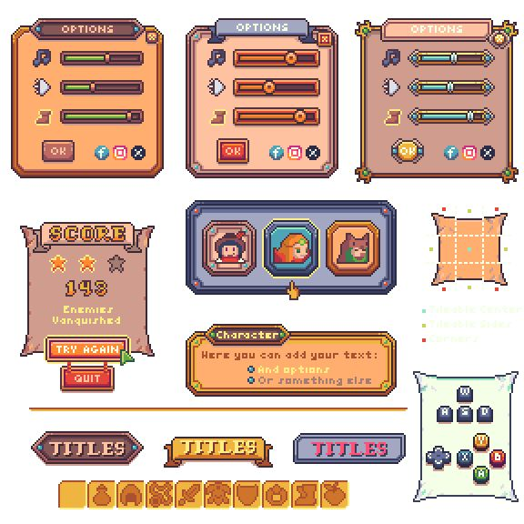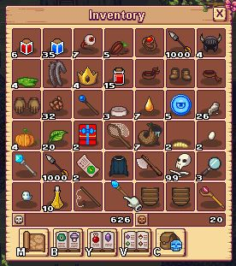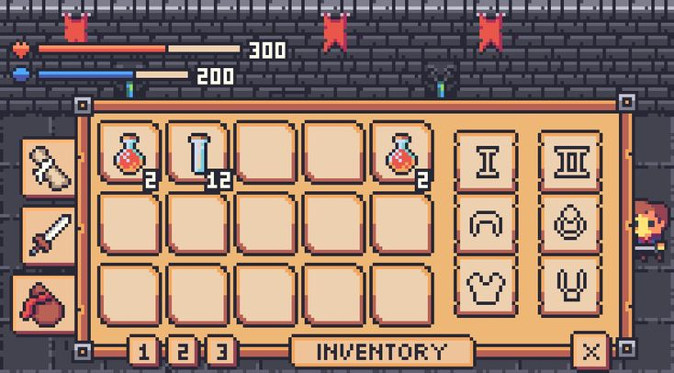

PPR:

These three images are one new theme: #14, a pixel-art fantasy game UI kit. It's separate from Pixel Retro (an OS desktop with window chrome) and from the Game Boy and CGA themes. This one is game interface: framed panels, slot grids, stat bars, and ribbon titles.
It also includes a 9-slice diagram (center, edges, corners), which tells the agent how these frames are meant to be built.

Breakdown
Layer | What's in the images
Tokens | Three palettes of one kit: warm orange, peach with slate-blue frame, and tan with teal accents. Each has 4 to 6 colors: a dark outline, 2 panel tones, a frame metal tone, and one accent. Pixel font in uppercase for titles.
Material | Flat pixel shading with a dark outline, a one-step highlight, and a one-step shadow on every surface. No gradients and no blur.
Shape | Chamfered pixel corners (a stepped diagonal), with studs or rivets on the corners. Title ribbons have swallowtail ends.
Components | Framed panel with a title tab, slider with segmented fill, inventory slot grid with count badges, stat bars (HP and mana), star rating, ribbon title banners (three styles), icon button row, hotkey keycaps, item toolbar, separator line, avatar selection frames with a highlighted choice, dialog with a title plate and bullet text
Ornament | Corner studs and rivets, ribbon folds, small gem details on the frame, a cursor hand

What makes it work
- 9-slice is the core mechanism. A frame is a center, four edges that tile, and four fixed corners. The kit shows this explicitly, and every panel, slot, and button is one of these.
- One outline color holds everything together. Every shape gets the same dark outline, and the fill colors change per palette.
- The slot is the repeated unit. The inventory is a grid of identical recessed cells, with a count badge in the bottom-right corner. A good slot part handles most of the screen.
- Variants are palette swaps. The same layout appears three times with different colors. That's a third test of the palettes mechanism.
- Hierarchy comes from the frame's weight. The main panel has a thick studded frame, while sub-panels such as slots and badges get thin ones.

What it adds to the contract
Addition | Notes
--nine-slice recipe | A frame defined as corner size, edge size, and fill. Implement with stepped box-shadow or border-image using data: SVG, which is allowed.
--outline | One outline color applied across all parts
slot and slotgrid | Recessed cell, optional count badge, optional selected frame, plus a grid container with a column count
statbar | Labeled bar with icon, fill color per stat, and a numeric readout
ribbon | Banner title with end caps, usable as header
keycap | Small keyed button for hotkey hints
stars | Rating row with filled and empty states
slider variant | Segmented fill with a framed thumb
Corner-stud ornament | Optional SVG snippet, applied by the 9-slice corners

Rules for the agent on this reference
- Draw original items and icons. The potions, swords, bags, skulls, and characters in these images are stand-ins. Don't copy them or any particular game's art.
- The portraits, enemies, and scene background (the brick wall, the character at the edge) are content. The theme frames them and never draws them.
- Ignore the social icons and the labeled "Titles", "Score", and "Inventory" text. Use neutral labels.
- Stay on integer --pixel-scale and image-rendering: pixelated, or the stepped corners blur.
- Palette limit: one outline, two panel tones, one frame tone, one accent per palette. Don't add colors beyond what each palette shows.
- Ship all three palettes. They count as palette tests, not separate themes.
- Difficulty: medium-high. AI models usually fail the 9-slice corners, so the agent should verify the frame at several panel sizes.

How it differs from the other pixel themes
 | Pixel Retro | Game Boy LCD | CGA neon | Game UI (new)
Subject | OS windows | Phone grid | Parody desktop | Game menus and inventory
Palette | One hue family | 2 inks | Fixed neon set | 3 palettes, 4 to 6 colors each
Key mechanism | Hard offset shadow | LCD grid, inversion | Dither presets | 9-slice frames, slots

Status
Fourteen themes are now in the plan, plus the XP category view as an extra reference. I'm still holding all additions for one update to theme-system-brief.md. The family list becomes:
- Bevel OS: Mac OS 8, Win98, XP, datautil
- Metal and instrument: Winamp, aqua-metal, dark-metal
- Flat pixel and mono: Pixel Retro, Game Boy LCD, CGA neon
- Game UI: the new kit
- Distinct: HUD, Leather, gel
At this size, the update should also cut round one to five themes that cover the five biggest mechanisms: bevel states (Win98), gloss and grain (aqua-metal), shape and ornament (HUD), 9-slice and slots (Game UI), and dense data (datautil). Leather and gel are the hardest materials, so they go in round two.
Send the next one, or tell me when you're done.

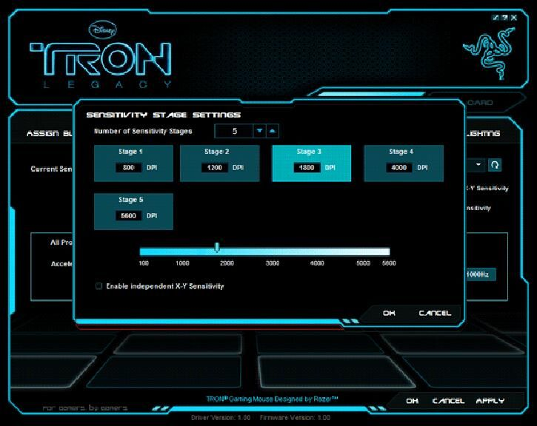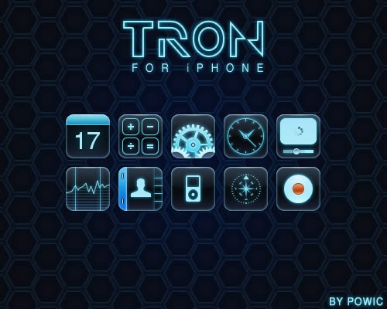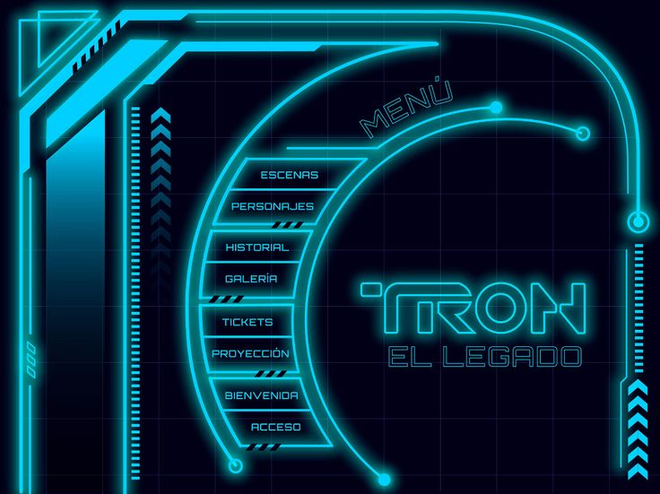

PPR:

These images are one new theme: #15, neon light-grid (Tron-style). It sits next to the coral HUD (Ref 2), but it's a different theme. The HUD is solid fills with no glow, in a single coral. This one is outline-only strokes that glow on black.

Breakdown
Layer | What's in the images
Tokens | Near-black navy #02080F-ish background, one cyan #1AD6FF-ish as the accent, a near-white cyan for "hot" highlights, dim teal #0B3A4A-ish for panel fills. Wide, geometric, uppercase type with generous letter-spacing.
Material | Glow is the material. Strokes get a layered glow (tight bright inner, wide soft outer). Panels are dark translucent teal with a thin cyan rim. Icon tiles are dark glass with a cyan edge highlight.
Shape | Chamfered and notched corners, long sweeping arcs, double-line borders, small hazard-stripe segments, chevron stacks
Components | Modal dialog (outlined frame, glowing bottom edge line), stage tiles (selected one fills solid cyan), numeric stepper with up and down arrows, gradient scale slider (dark to white-cyan track with tick labels), checkbox, outlined text buttons (OK, Cancel, Apply), tab labels, arc menu (a curved stack of menu rows), icon tile grid
Ornament | Hex grid (or square grid) background, corner brackets, dot-and-line terminals, chevron columns, tick marks, hazard stripes

What makes it work
- Outline plus glow replaces fill. Hierarchy comes from stroke weight and glow strength. Solid fill is reserved for the single selected item (stage 3 here), which makes selection unmistakable.
- One hue on black. No second accent. Brightness (dim teal, cyan, near-white) does all the hierarchy work.
- The grid background is structural. It gives the theme depth without any shadows. It should be an ornament or --grid-bg token built from an inline SVG pattern, never an image file.
- Glow needs a ceiling. Too many layers wash out text. Keep body text un-glowed or lightly glowed and keep contrast readable.
- Dark glass tiles (the icon grid) use a darker fill with a one-pixel lighter top edge and a cyan rim, so they read as lit from within.

How it differs from the coral HUD
 | Coral HUD (Ref 2) | Neon grid (new)
Material | Flat solid fills, no glow | Outline strokes with glow
Palette | Coral on plum | Cyan on near-black
Selection | Solid fill color | Solid fill cyan, rest outline
Ornament | Binary, barcode, captions | Hex grid, chevrons, arcs, hazard stripes
Shape | Chamfers only | Chamfers plus arcs and sweeps
They can share one family (hud) and one parts map. Keep them as two separate themes with their own materials.

What it adds to the contract
Addition | Notes
--glow-color, --glow-inner, --glow-outer | Replaces the single --glow from the gel theme with explicit layers
--stroke-width, --stroke-style | For outline-first themes (single, double, notched)
--grid-bg | Background grid token built from an inline SVG pattern
arcmenu part | Curved stack of menu rows. Optional, with a straight-list fallback when SVG paths aren't supported
stepper part | Numeric field with up and down controls
slider variant: scale | Gradient track, tick marks, labeled scale, framed thumb
optiontile part | Selectable tile with an inner value field. Selected state = filled
Reduced-effects mode | Required here too: cap glow layers and drop filter effects when prefers-reduced-motion or a low-power flag is set

Rules for the agent on this reference
- No film, studio, or hardware brands. Don't reproduce the film's logo or lettering, the studio mark, the gaming-peripheral logo, the "designed by" lines, or the "for iPhone" title. Make an original, plain wordmark placeholder.
- Original icons only. The glass icon tiles imitate phone-app icons (calendar, calculator, gear, clock, contacts, music player, compass). Draw generic originals.
- The Spanish menu text and the DPI values are stand-in content. Use neutral labels.
- Build glow with box-shadow, drop-shadow, and SVG strokes only. No bitmap images.
- Check contrast: body text must stay readable against the grid. Add it to the checklist.
- Difficulty: medium. Models over-glow and under-contrast.

Status
Fifteen themes are now in the plan (plus the XP category view as a second reference). The families:
- Bevel OS: Mac OS 8, Win98, XP, datautil
- Metal and instrument: Winamp, aqua-metal, dark-metal
- Flat pixel and mono: Pixel Retro, Game Boy LCD, CGA neon
- Game UI: the pixel fantasy kit
- HUD: coral HUD, neon grid
- Distinct: Leather, gel
I'm still holding every addition for one update to theme-system-brief.md. The brief is getting large, so I'd suggest consolidating now: I fold in all the new themes, refined rules, and contract additions, and re-organize the build phases by family. You can still add references afterward as short appendices. Want me to do that, or send more first?

THE BIG ONE [UI TVA]

Appendix: Theme tva (Theme #16): Retro-futurist bureaucracy
Companion to theme-system-brief.md. Uses the same contract (channels, tokens, parts, states, loader, security rules). Nothing here changes the contract except the additions listed in section 9.
Private use only, but original stand-ins are still required (decision from Q&A). Never reproduce the show's emblem, mascot, characters, artwork, or title lettering.
Reference images: I will attach screenshots of the show's sets, screens, and signage. Use them to calibrate every provisional value marked (provisional) below. If a screenshot contradicts this brief, the screenshot wins, and you tell me what changed. Do not mix traits from any other theme.

1. Research basis and confidence
Claim | Confidence | Where it shows up
Creative brief: "Mad Men meets Blade Runner" | High (production designer and creator interviews) | Overall mood
Intentional paradox: huge stoic brutalist forms vs. mid-century-modern surfaces, palette, and playful patterns | High | Shape and material split
Warm palette of brown, red, gold; whimsical patterns; orange plastic fixtures; orange with brown and grey with chartreuse as era pairings | High / medium | Palette
Yellow tungsten lighting, sepia-tinted saturated look, 1950s-style public-info posters | Medium | Screen tint overlay, poster styling
Signage branding described by the designer as roadside-station style: bold type and color combinations | High | Signage
Oversized mid-century "supergraphics" | High | Supergraphic mode
Stepped, blocky, ziggurat-like building language | Medium | Frame shape
CRT-style screens are mostly green with amber variants, handheld video is digitized to monochrome 8-bit, orange tint echoes 1970s SELF-SCAN displays | High | Screen layer
Monitors were built props, not real CRTs, with graphics added in post. Chronomonitors have rounded, organic housings | High | Screen housing shape
Graphics blend 1960s aesthetics with 1980s tone | Medium | Type and screen mix
A "muted grey, brown, sickly green" palette | Low (low-quality sources, conflicts with the designer) | Not used. At most, a possible screen-only effect
Exact typeface | Unverified. Never claim a font is "the" TVA font | Use "geometric sans in the style of"

2. Decisions locked in Q&A
Question | Decision
Surfaces | CRT and monitor screens + architecture and signage. No full office-paperwork surface, apart from the stamp and field parts below
Realism | Hybrid: flat graphic signage and frames around skeuomorphic screens
Palettes | One palette: Warm office. No green or amber screen palette
Supergraphic signage | Both, switchable via --supergraphic: on/off
CRT effects | Both, switchable via `--crt-level: off
Shape | Blocky frames, rounded screens
Type | Geometric sans + mono for screens
Extra parts | Timeline visualizer, department header, stamp + form field
Motion | Subtle, all disabled under reduced-motion
Naming | Original stand-ins
Note: with only one palette, screens use the warm orange-amber ink on dark brown-black, a monochrome screen ink derived from the same palette (described in the sources as an orange tint). Do not add green.

3. Style summary
A bureaucracy built from mid-century office design and Cold-War brutalism. Heavy blocky frames and flat, bold signage, with warm brown, orange, and gold surfaces, wrapped around rounded, glowing monochrome screens. It should feel friendly on the surface and a little oppressive underneath. No gloss, no glass, no gradients on chrome.
Signature details (must be present):
- Heavy stepped or blocky frame with flat, matte color blocks
- Oversized geometric supergraphic shape behind content when --supergraphic: on
- Rounded monochrome screen with an orange-amber ink, scanline and glow effects scaled by --crt-level
- Uppercase geometric-sans signage with a department code
- A stamped status label

4. Tokens (all values provisional; calibrate from screenshots)
Color (Warm office):
Token | Starting value | Role
--bg | #2A1D14 | Deep brown, page background
--surface | #EDE0C4 | Cream paper and laminate
--surface-2 | #D9C7A0 | Darker cream, secondary panels
--text | #2B1A10 | Dark brown ink
--text-dim | #6B5338 | Secondary text
--accent | #D9822B | Orange, main brand block
--accent-2 | #E0A82E | Gold, highlights and signage blocks
--danger | #9A3B26 | Red-brown, stamps and warnings
--ok | #7C8A3A | Muted chartreuse (era pairing), used sparingly
--screen-bg | #16100A | Near-black brown screen
--screen-ink | #FFA63D | Orange-amber screen ink
--screen-ink-dim | #8A5320 | Dim screen ink
--tint-tungsten | rgba(255,190,90,.08) | Optional warm sepia overlay
Screens use only --screen-bg, --screen-ink, --screen-ink-dim. Selected and inverted states swap bg and ink. No other colors on a screen.
Type:
Token | Value
--font-ui | System geometric-sans stack (e.g. "Jost", "Century Gothic", "Futura", "Avenir Next", system-ui, sans-serif). Never claim it is the show's font.
--font-display | Same family, bold, uppercase, wide tracking
--font-mono | System monospace for screens (ui-monospace, "Courier New", monospace)
--font-screen | Monospace or a data-URI pixel face for CRT text
Shape:
Token | Value
--radius-window, --radius-control, --radius-chip | 0 (frames and controls are blocky)
--radius-screen | 14px to 28px (rounded screens, provisional)
--cut-* | Stepped corner via clip-path, 2 to 3 steps (ziggurat feel), optional
--bevel-width | 0 (no bevels)
Material: --shadow-hard: 4px 4px 0 var(--bg) for flat layering. No soft shadows, no gradients on chrome. Optional subtle --grain (paper) as an SVG feTurbulence at very low opacity.
New tokens: --supergraphic (on/off), --supergraphic-shape (preset name), --crt-level (off/light/full), --scanline-opacity, --phosphor-glow, --screen-curve, --tint-tungsten.

5. Part styling
Part | Treatment
window, panel | Heavy flat cream block, thick dark-brown outline, stepped or blocky silhouette, hard offset shadow
titlebar, header | Solid orange block, uppercase geometric sans, a small code tag on the right
sidebar | Dark brown block with gold index markers
tabstrip, tab | Flat folder-style tabs, selected = filled orange, idle = cream
button primary | Solid orange block, uppercase, dark text, pressed = shift 2px into its shadow
button secondary | Cream block, thick outline
button icon/transport | Square with a thick outline. No round gel or glass
toggle, switch | Chunky rocker or slab, orange = on
checkbox, radio | Square and circle, thick outline, filled mark
slider | Flat track, blocky thumb, tick marks
list, listrow | Flat rows with a code column and a colored status block
datagrid | Cream rows, dark header, selected row = orange
badge, chip | Flat labels, uppercase
alert, dialog | Block frame with a hazard-free header bar, stamp for status
statusbar | Dark brown strip, gold text
scrollbar | Block thumb, flat arrows
screen | Rounded recessed display inside a heavy bezel. Contains readout, visualizer, and the timeline. Uses the screen palette only
readout | Monospace, orange-amber on dark, blinking cursor, optional glow
visualizer | Text-glyph or block bars in screen ink
Content (photos, thumbnails) is never recolored. The surface it sits on is part of the theme.

6. New parts (add to the contract, see section 9)
timelinechart
- A branching timeline drawn on a screen: a horizontal main line, side branches, node markers, labeled ticks.
- Inline SVG, one ink. Branch nodes, a "pruned" branch style (dashed), and a current-position marker.
- Must work as a generic history, version, or flow chart for any app.
deptheader
- Signage-style header: department code (e.g. DEPT. 04), uppercase title, and an optional supergraphic block.
- Three variants: block (solid color), stripe (title on a stripe), poster (large type over a supergraphic).
stamp
- Rubber-stamp status label: uppercase, thick outline, rotated 2 to 4 degrees, slight ink-texture mask via SVG filter.
- Variants: approved, pending, denied, void. Colors from --ok, --accent, --danger, --text-dim.
formfield
- Paperwork-style input: label above, ruled underline, a small field code on the left, mono entered text.
- States: idle, focus (thick underline plus code highlight), error (red stamp-style marker), disabled.

7. Supergraphic mode
When --supergraphic: on:
- Oversized geometric shapes (stepped blocks, large arcs, bold stripes) sit behind content at 10 to 30% opacity or as flat blocks in --accent and --accent-2.
- Large uppercase geometric-sans type may run across a panel edge, cropped.
- Content layers stay readable: body text needs enough contrast over any supergraphic (check this).
When off: all supergraphics are removed, spacing tightens, and the theme remains complete. Required for dense apps.
Supergraphics are original SVG presets (stepped-blocks, stripe-pair, arc-quarter). Do not trace any set photo.

8. Screen and motion rules
--crt-level:
Level | Effect
off | Flat monochrome pixel/mono text, no overlays
light | Faint scanlines (--scanline-opacity low), slight glow on ink
full | Scanlines, glow, subtle curvature (--screen-curve), slight vignette
All effects use CSS gradients, text-shadow, filter, and SVG only. No bitmap images. A prefers-reduced-motion or low-power flag forces off for animated parts and caps glow layers.
Motion (subtle, all disabled under reduced-motion):
- Screen boot-in: a brief fade or line-expand on first render
- Blinking cursor in readout and formfield
- A gentle flicker at full only, amplitude very low
- Button press: 2px translate, 80ms
- Tab and state changes: 120ms ease
- No pulsing glows, no scrolling tickers, no looping decoration

9. Contract additions needed
Addition | Detail
Tokens | --supergraphic, --supergraphic-shape, --crt-level, --scanline-opacity, --phosphor-glow, --screen-curve, --tint-tungsten, --radius-screen, --font-screen
Parts | screen, timelinechart, deptheader, stamp, formfield
Ornament presets | stepped-blocks, stripe-pair, arc-quarter
Checks | Supergraphic contrast check, screen-palette check (only the three screen tokens appear inside screen)
Reuse before adding: screen and readout should reuse the screen and readout logic from the other CRT and LCD themes where possible. Report any contract change before continuing, as in the main brief.

10. Rules for the agent
- Original everything. Original emblem, organization name, department names, mascot-free. No show logo, no mascot, no characters, no title lettering, no poster art, no recognizable set graphics.
- No show-specific terms in sample text. Use neutral stand-ins such as "Department of Records," "Case file 0417," "Status: Pending."
- Do not claim a font is the real one. Describe the type as "geometric sans in the style of mid-century signage."
- Palette discipline. Warm office palette only. No green, no purple, no blues, and nothing added for "variety."
- No gloss, no glass, no bevels, no soft shadows on chrome. The hard offset shadow is the depth model.
- Screens use only the three screen tokens.
- Hardware is blocky and screens are rounded, never the reverse.
- Ignore photos and set details in screenshots that are not UI (actors, props, backgrounds).
- Calibrate colors from the attached screenshots, then report the final hex values and any that differ materially from section 4.

11. Acceptance checklist
- [ ] All required tokens plus the section 4 additions defined
- [ ] All parts and all six states styled, including screen, timelinechart, deptheader, stamp, formfield
- [ ] Passes Test Page A and Test Page B, plus a TVA test card (deptheader + screen with timelinechart + formfield + stamp + datagrid)
- [ ] --supergraphic on and off both look complete, with readable text in both
- [ ] --crt-level off, light, and full all work, and reduced-motion forces off
- [ ] Screen contains only the three screen tokens
- [ ] No forbidden constructs (validator clean)
- [ ] No show marks, characters, or lettering anywhere
- [ ] Looks like only itself, with no traits from the coral HUD, neon grid, or any CRT/LCD theme
Difficulty: medium-high. The usual failures: adding gloss, softening the shadows, leaving a green tint on the screens, making the supergraphic too busy to read over, and over-applying scanlines.

12. Open items
- Calibrate all (provisional) hex values from my screenshots
- Confirm the supergraphic shape presets against the screenshots, since they are originals inspired by the genre
- If a second palette is wanted later (screen-only green or amber), it is a palette addition and requires no structural change

Sources (research)
- The Art Newspaper, production designer interview: https://www.theartnewspaper.com/2021/07/10/lokis-production-designer-on-the-modernist-inspiration-behind-the-shows-stunning-visuals
- IndieWire summary of the "Mad Men meets Blade Runner" brief and Brazil reference: https://s.media-imdb.com/news/ni63368858/
- Yahoo Entertainment, signage and palette breakdown: https://www.yahoo.com/entertainment/look-loki-influenced-mad-men-185834234.html
- Yahoo Entertainment, brown/red/gold palette and carpet patterns: https://www.yahoo.com/entertainment/loki-brazil-blade-runner-influenced-213023224.html
- Collider, production design interview (supergraphics, built monitors): https://collider.com/loki-production-design-cat-kasra-farahani-interview/
- What to Watch, aesthetic breakdown (orange plastic, era palette): https://whattowatch.com/features/loki-breaking-down-the-aesthetic-of-the-tva
- Retro hardware interview coverage (CRT colors, 8-bit handheld look): https://techyes.pages.dev/2021/7/13/22574400/loki-retro-hardware-tempad-kasra-farahani-interview-marvel-disney-plus
- Cantina Creative, screen graphics studio: https://cantinacreative.com/series/loki and https://digitalmediaworld.tv/in-depth/395-rodeo-fx-takes-lucy-on-a-collision-course
- Before & Afters, screen graphics process (60s/80s mix): https://beforesandafters.com/2021/08/10/designing-the-sacred-timeline-in-loki/
- Typeface discussion (unverified, low confidence): https://madegooddesigns.com/?p=10831
- Low-confidence palette claim, not used: https://discourse.weareopen.coop/news/lokis-tva-unpacking-its-unique

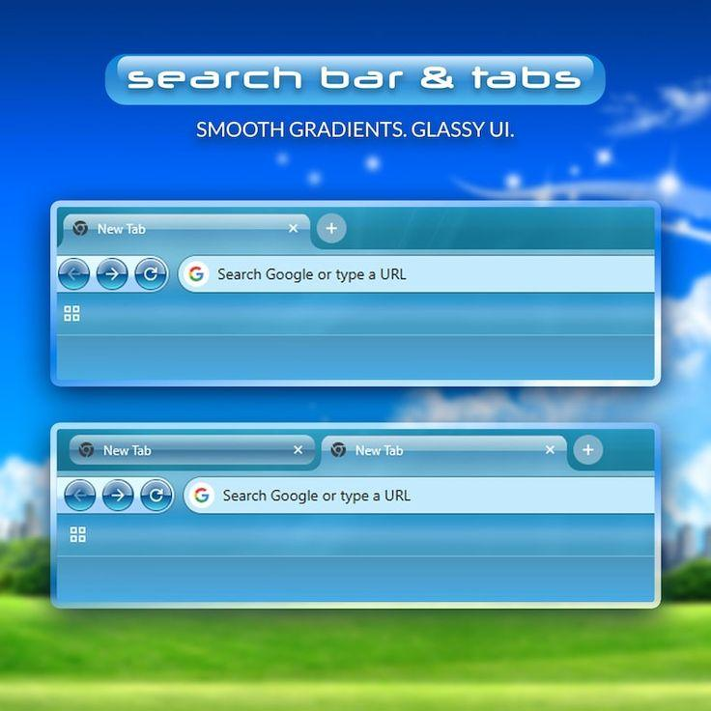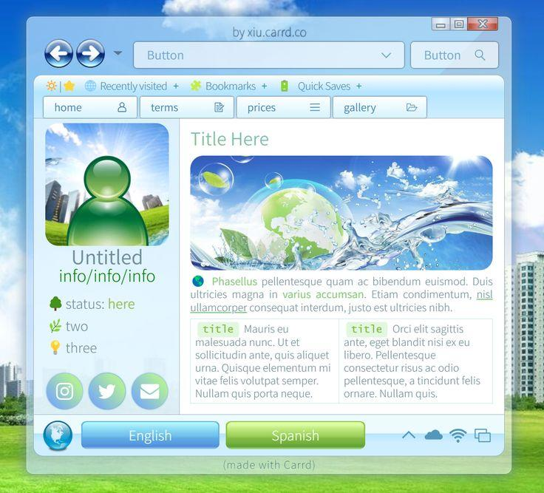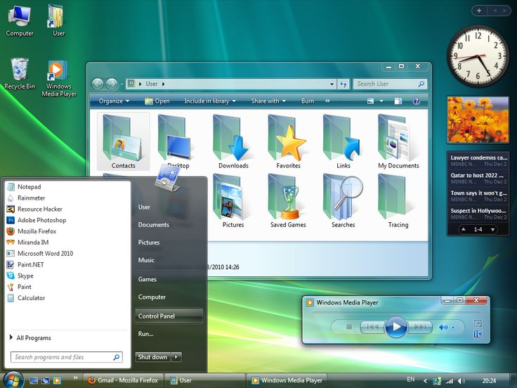

PPR:

These four images are one new theme: #17, Aero glass (Vista-era translucent UI). It's related to the gel theme (#13), but it's a different theme. Gel is opaque, glossy objects with colored shadows. This is translucent window chrome: frosted glass frames over a bright wallpaper, with a light content area inside. I'd put them in one frutiger family that shares the gloss recipes and parts map. If you'd rather fold this into gel, say so.

Breakdown
Layer | What's in the images
Tokens | Two palettes. Sky: cyan-blue glass with fresh lime-green accents (images 1 and 2). Teal: blue-green glass with a dark teal command bar (images 3 and 4). White or very pale content areas, dark slate text, green section titles. Clean humanist sans (Segoe/Frutiger feel, system stack).
Material | Frosted glass: translucent tint plus blur, a 1-px white inner edge and a soft outer glow, a diagonal glare streak across the frame, and glossy highlight bands on buttons and bars. Content sits on opaque white.
Shape | Rounded window frame (about 8 to 12px), rounded tabs with a curved join to the toolbar, round orb back/forward buttons, pill and rounded-rect fields, circular social buttons
Components | Glass tab strip with a "+" tab, orb nav buttons (back, forward, reload), address field with a dropdown, search field with an icon, caption buttons (small min and max, wide red close), tab row with icons, breadcrumb address bar, menu bar, command bar (dark gradient with labeled buttons and dropdown arrows), left pane with Favorite Links and a Folders tree, column headers with a sort arrow, icon-grid view, preview/details pane, glossy blue and green action buttons, avatar tile, round icon buttons, taskbar and start menu in dark glass
Ornament | Wallpaper (sky, clouds, grass, bubbles, sparkles), glass glare streak, translucent folder icons

What makes it work
- Glass needs something behind it. Over a flat white page, a translucent frame looks wrong. The theme must supply a --wallpaper token (an original gradient with soft clouds, bubbles, and sparkles built from CSS and SVG) behind the window layer.
- The frame is glass and the content is not. Translucent tinted chrome, opaque white content. That split is the look.
- Glare plus inner edge = glass. A white 1-px inner border, a faint diagonal highlight, and a bright top edge sell it. Blur alone looks like frosted plastic.
- Orbs for navigation, rectangles for everything else. Back, forward, and reload are round glossy buttons with a ring. The rest of the toolbar is flat, labeled, and dense.
- Two button colors carry state. Blue gloss for default or primary, green gloss for the secondary or "go" action. Same material, different hue.
- Dark glass for system surfaces. The command bar, taskbar, and start-style menus go dark teal, which gives the light content area contrast.

What it adds to the contract
Addition | Notes
--glass-tint, --glass-border, --glass-glare | The gel theme already has --glass-blur and --glass-alpha. These extend them
--wallpaper | Theme-supplied background layer, so glass has something to blur. Original art only
--frame-glow | Soft outer glow on window frames
navorb part | Round glossy back/forward/reload button with a ring
addressbar + breadcrumb | Path segments with separators, a dropdown, and a refresh button
commandbar part | Dark gradient strip with labeled buttons, icons, and dropdown arrows
searchfield part | Inline field with a placeholder and an icon
sidebar variants | Collapsible sections ("Favorite Links", "Folders") with a tree
previewpane | Bottom details strip with a thumbnail and metadata
Caption buttons | Joined min/max pair and a wide red close button
Fallback mode | Where backdrop-filter is unsupported or effects are reduced: opaque tinted panels with the same gradients

Rules for the agent on this reference
- Original icons only. Don't reproduce the folder icons, the start orb, the OS flag, the media player, the browser's logo, the search engine's "G," or the social network icons. Draw generic translucent folder, globe, star, and magnifier icons.
- The wallpaper, photos, and avatar art are content or stand-ins. The theme provides its own original wallpaper and never copies these.
- Ignore text overlays. That covers the credit lines ("made with…"), the headline caption, the gadget widgets, and the news ticker. They aren't part of the theme.
- Contrast check: text on glass must stay readable over any wallpaper. Light chrome gets dark text, and dark glass gets white text with a faint dark text-shadow.
- Reduced-effects mode is required. backdrop-filter is expensive, so the theme must degrade to opaque tints under reduced-effects or a low-power flag.
- Palettes change color tokens only, never the glass recipe.
- Difficulty: high. Models usually overdo the blur, lose text contrast, forget the glare streak, or leave the glass over a flat background.

How it differs from nearby themes
 | XP Luna (#7) | Gel (#13) | Aero glass (new)
Frame | Opaque blue gradient | No window frame | Translucent blurred glass
Body | Cream beige | n/a | White, opaque
Signature | Title bar gradient | Specular highlight on objects | Glare, inner edge, orb buttons
Shadow | Soft gray | Colored | Soft glow plus tint
Depends on | Nothing | Nothing | A wallpaper behind it

Status
Seventeen themes are now in the plan, plus the XP category view as a second reference. Families:
- Bevel OS: Mac OS 8, Win98, XP, datautil
- Metal and instrument: Winamp, aqua-metal, dark-metal
- Flat pixel and mono: Pixel Retro, Game Boy LCD, CGA neon
- Game UI: the pixel fantasy kit
- HUD: coral HUD, neon grid
- Frutiger: gel, Aero glass
- Distinct: Leather, TVA (separate appendix)
Send the next one, or say "consolidate" and I'll fold everything into one brief with the TVA appendix attached.

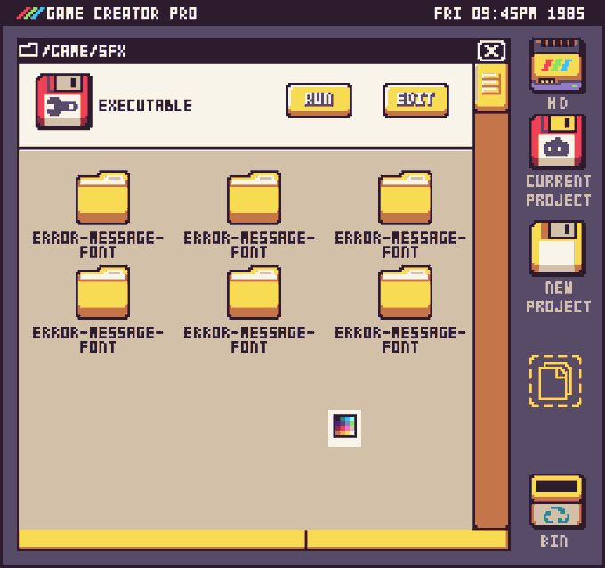

PPR:

The first image is a new theme, #18, a fantasy-console desktop OS. The second image is the pixel fantasy game UI kit from earlier (#14), unchanged, so nothing is added from it.
This one is a retro home-computer desktop with a file manager, drive icons, and a clock reading "1985." It sits in the flat pixel family but stays separate from Pixel Retro (#5), which is a periwinkle window desktop, and from CGA neon (#12), which is a fixed neon palette.

Breakdown
Layer | What's in the image
Tokens | A fixed warm palette of about 8 colors: deep plum-navy frame and desktop (#2E2A3E-ish), cream header panel, tan content area, saturated yellow for buttons and folders, burnt-orange for the scrollbar and folder shading, red for the floppy, plus one rainbow accent in the top-left logo. A monospace-looking pixel font in uppercase, with every label the same size.
Material | Flat fills, 1-px dark outlines, a two-step shade on each object (a lighter face and a darker lower edge, as on the folders). No gradients, no blur, no soft shadows.
Shape | Square windows. Buttons and tiles have stepped, slightly cut corners. Icons sit on a chunky 2x pixel grid.
Components | A top system bar (logo, title, date and clock), a window with a path title bar and a boxed close button, a header strip with a file icon, a type label, and two yellow action buttons (RUN, EDIT), a file grid (folder icon plus label), a vertical scrollbar with a yellow grip, a bottom segmented strip (progress or status), and a vertical drive dock on the right (HD, CURRENT PROJECT, NEW PROJECT, BIN)
Ornament | A dashed-outline "new file" drop target, a rainbow stripe logo, a tiny color-swatch cursor

What makes it work
- The metaphor is a floppy-disk computer. Floppies stand for save, load, and projects. The icon set is part of the theme: floppy, drive, folder, bin.
- The dock is the app's global navigation. A column of labeled drive icons works as a sidebar for any app (sections, projects, trash).
- Everything snaps to one pixel scale. Icons, borders, and type should use the same --pixel-scale. One off-grid element breaks the illusion.
- Yellow means action. The buttons, folders, and scroll grip all use the same yellow. It's the single "interactive" color, so state needs no extra hues.
- Two background tones separate zones. Cream is for the header and controls, and tan is for browsing. Hierarchy comes from that contrast and not from shadows.

What it adds to the contract
Addition | Notes
systembar part | Top strip with a logo slot, a title, and a live date and clock. It's different from menubar and statusbar, and apps can use it for headers
dock vertical variant | The dock from the Game Boy theme was horizontal. This needs orientation: vertical
icontile + filetile | Merge them: icontile with a layout variant for grid items
dropzone part | Dashed outline "new item" target
Segmented progress | A flat segmented strip at the bottom of a window
--palette-colors | Reuses the fixed-palette check from the CGA theme. Here the list has about 8 entries
Required icon slots | drive, floppy, folder, bin, newfile

Rules for the agent on this reference
- Original icons and logo. Don't copy the floppy, drive, and folder icons pixel for pixel, and don't reproduce the rainbow-stripe logo or any real computer brand's mark. Draw a different small logo.
- Neutral stand-in text. The title ("GAME CREATOR PRO"), the folder names, and the 1985 date are placeholders. Use generic labels and a real clock.
- Palette discipline. Keep to the listed palette. No new hues, no gradients, no soft shadows.
- Integer pixel scale with image-rendering: pixelated, and a pixel font as a system stack or data-URI.
- Check at several window sizes, since stepped corners and 1-px outlines blur at fractional scaling.
- Difficulty: low to medium.

How it differs from the other pixel themes
 | Pixel Retro (#5) | CGA neon (#12) | Game Boy LCD (#11) | Console OS (new)
Palette | Periwinkle family | 4 to 5 neon colors | 2 inks | ~8 warm colors
Subject | Windows and dialogs | Parody desktop | Icon grid | File manager and drive dock
Depth | Hard offset shadow | Dither | Dither and LCD grid | Two-step shaded objects
Unique part | Property rows | Tool and swatch palettes | LCD overlay | System bar and vertical dock

Status
Eighteen themes are in the plan, plus the XP category view as an extra reference. Families:
- Bevel OS: Mac OS 8, Win98, XP, datautil
- Metal and instrument: Winamp, aqua-metal, dark-metal
- Flat pixel and mono: Pixel Retro, Game Boy LCD, CGA neon, Console OS
- Game UI: the pixel fantasy kit
- HUD: coral HUD, neon grid
- Frutiger: gel, Aero glass
- Distinct: Leather, TVA (separate appendix)
At this size, the main brief is long enough that one consolidated pass will save the agent real confusion. Send the next one, or say "consolidate" and I'll fold everything into one brief with the TVA appendix attached.

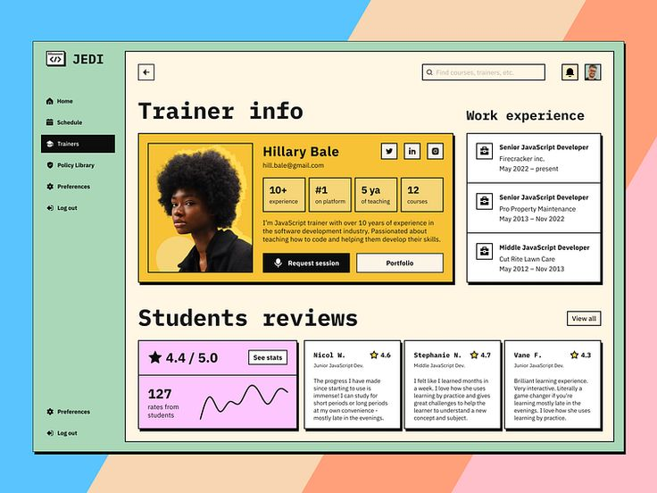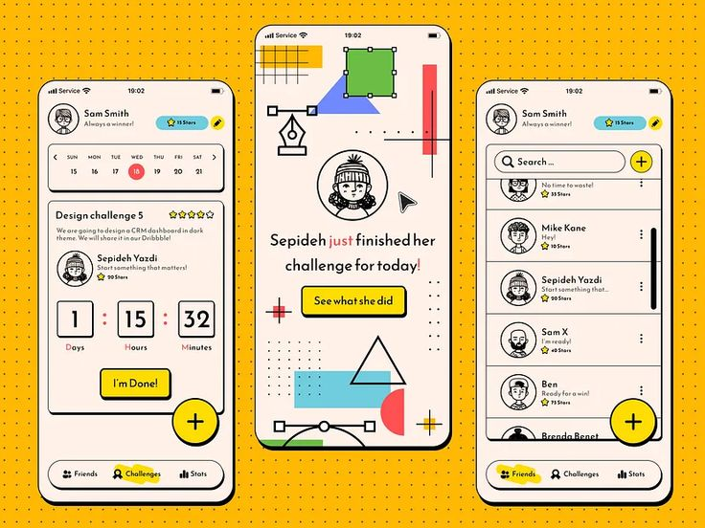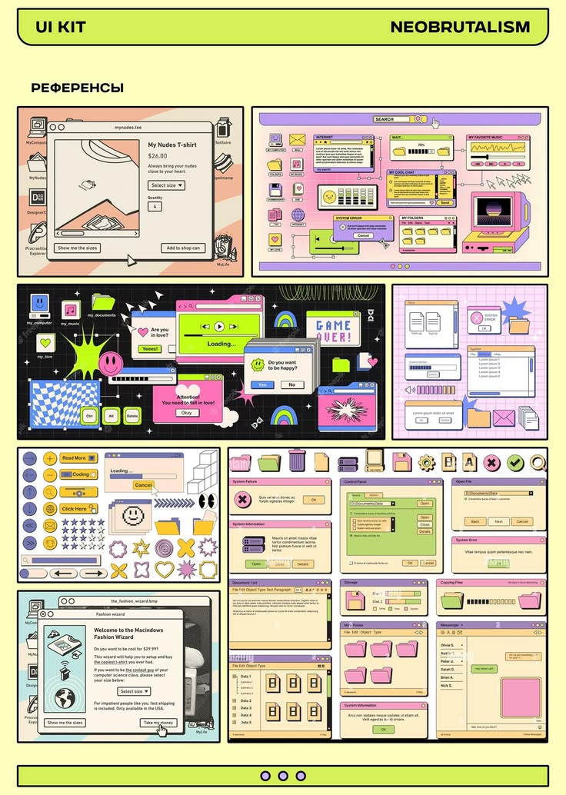

PPR:

No, we don't have this one. It's a new theme, #19, neobrutalism. The closest existing themes are Pixel Retro (#5), which also uses hard shadows but with a pixel font and a single periwinkle hue, and Win98 (#6), which has retro window chrome but uses bevels. Neither covers thick black outlines on bright flat pastels.
All three images are one theme. The first is a web dashboard, the second is a mobile app, and the third is a UI-kit sheet that applies the same style to parody retro-OS windows.

Breakdown
Layer | What's in the images
Tokens | Cream (#FFF6E0-ish) as the base surface, pure black outlines and text, and a rotating set of flat pastels used as block colors: sunny yellow, mint green, pink, lavender, sky blue, peach, lime. The mobile screens use a saturated yellow backdrop with a dot pattern. One bold accent per screen area.
Type | A monospace or grotesque face in bold for headings (large "Trainer info"), a plain sans or mono for body. High contrast, no light weights.
Material | None. Flat fills, a thick black outline (about 2 to 3px), and a hard offset shadow (solid black, no blur) on cards, buttons, and windows.
Shape | Mostly rounded rectangles with a small radius, circles for avatars and the floating action button, pill for tab bars and search. Stickers use star, flower, and burst shapes.
Components | Sidebar with a black selected row, card with a colored header band, stat tile (big number over a label), tag/chip, icon-in-box button, search field with an icon, avatar tile with a colored backdrop, review card, rating row, line-chart tile, calendar strip, countdown tiles, list with avatars and star counts, bottom pill tab bar with a highlighter-marker underline on the active tab, floating action button, toast-style retro dialog windows, scrollbar
Ornament | Dot grid, diagonal pastel stripes, geometric doodles (circles, triangles, lines with handle squares), stickers (smiley, burst, flower), hand-drawn line avatars

What makes it work
- The outline and the hard shadow are the whole system. Every container is outlined, and every raised thing has the same solid offset. If either is missing, it reads as plain flat design.
- Color is assigned by role, not mixed. Each block gets one flat pastel. Yellow means primary or highlight, pink means feature or stats, and green means navigation or secondary. Don't gradient or blend.
- State is a position change. Hover lifts the element (the shadow grows), and pressed collapses it into its shadow (translate by the shadow offset). Selected means black fill with white text, as in the sidebar.
- Big type and tight grids. Headings are large and bold, and layouts are strict boxes with consistent gaps.
- One playful device per screen. A sticker, a doodle, or the highlighter underline. It stops the theme from looking like a wireframe.
- The retro-OS sheet is the same material on different parts. Title bars, close boxes, progress bars, and error dialogs get outline, hard shadow, and pastel fills.

What it adds to the contract
Addition | Notes
--outline-width, --outline-color | One outline token for all parts (Game UI already has --outline, so reuse it and add the width)
--shadow-hard | Exists. Add --shadow-hard-hover and --shadow-hard-press offsets so state is token-driven
--palette-role-* | Named pastel roles (--block-yellow, --block-pink, --block-mint, --block-lilac, --block-sky) so apps pick a block color by role
statblock | Exists. Add a colored-background variant
fab part | Floating action button, circular
marker ornament | Highlighter-style underline behind the active tab label
sticker ornament | A small set of original star, burst, and flower shapes
countdown part | A row of numbered tiles with unit labels
tabbar variant | Bottom pill bar for phone-width layouts
Dot-pattern background | --bg-pattern as an inline SVG pattern

Rules for the agent on this reference
- Original illustrations and stickers. Don't copy the line-art avatars, the doodle set, or the retro icon set. Draw simple original shapes. The people photos and avatar art are content, never part of the theme.
- Ignore all text, brands, and logos. That covers the platform name, the "JEDI" wordmark, the mock store and shirt copy, the parody OS name, the Cyrillic labels, and the "UI kit" heading. Use neutral stand-in text.
- No brand marks from real OSes or apps. The retro-OS sheet parodies the Windows and Mac look, so keep the parody out and use generic chrome.
- Strict outline and hard shadow on everything that is a container or control. No soft shadows, gradients, glass, or bevels.
- Pastel discipline. Flat fills from a fixed set per theme. A palette may swap the set but never adds gradients.
- Ship two palettes: one cream-and-mint (web) and one yellow-and-cream (mobile). Palettes change color only.
- Check contrast: black text on every pastel must pass, and keep white-on-black for selected states.
- Difficulty: low. The usual failures are soft shadows, thin outlines, and too many colors on one screen.

How it differs from nearby themes
 | Pixel Retro (#5) | Win98 (#6) | Leather (#3) | Neobrutalism (new)
Outline | 1 px | 2-px bevel | None | 2 to 3 px black
Shadow | Hard, small | Bevel | Soft, layered | Hard, large
Palette | One hue family | Gray + navy | 2 browns, 2 creams, brass | Cream + black + rotating pastels
Type | Pixel font | System sans | Serif + sans | Bold mono/grotesque
Works for | Windowed apps | Windowed apps | Skeuomorphic apps | Dashboards, mobile, web
This one is also the strongest candidate so far for everyday apps (dashboards, social, learning), since it works at phone and desktop widths with no special rendering.

Status
Nineteen themes are in the plan, plus the XP category view as an extra reference. Families:
- Bevel OS: Mac OS 8, Win98, XP, datautil
- Metal and instrument: Winamp, aqua-metal, dark-metal
- Flat pixel and mono: Pixel Retro, Game Boy LCD, CGA neon, Console OS
- Game UI: the pixel fantasy kit
- HUD: coral HUD, neon grid
- Frutiger: gel, Aero glass
- Flat graphic: neobrutalism
- Distinct: Leather, TVA (separate appendix)
The list is long enough now that a single consolidated brief will keep the agent from getting lost. Say "consolidate" and I'll fold in everything, including the TVA appendix, the XP category view, the refined "surface vs. content" rule, and the family-based build phases. Or send the next reference first.

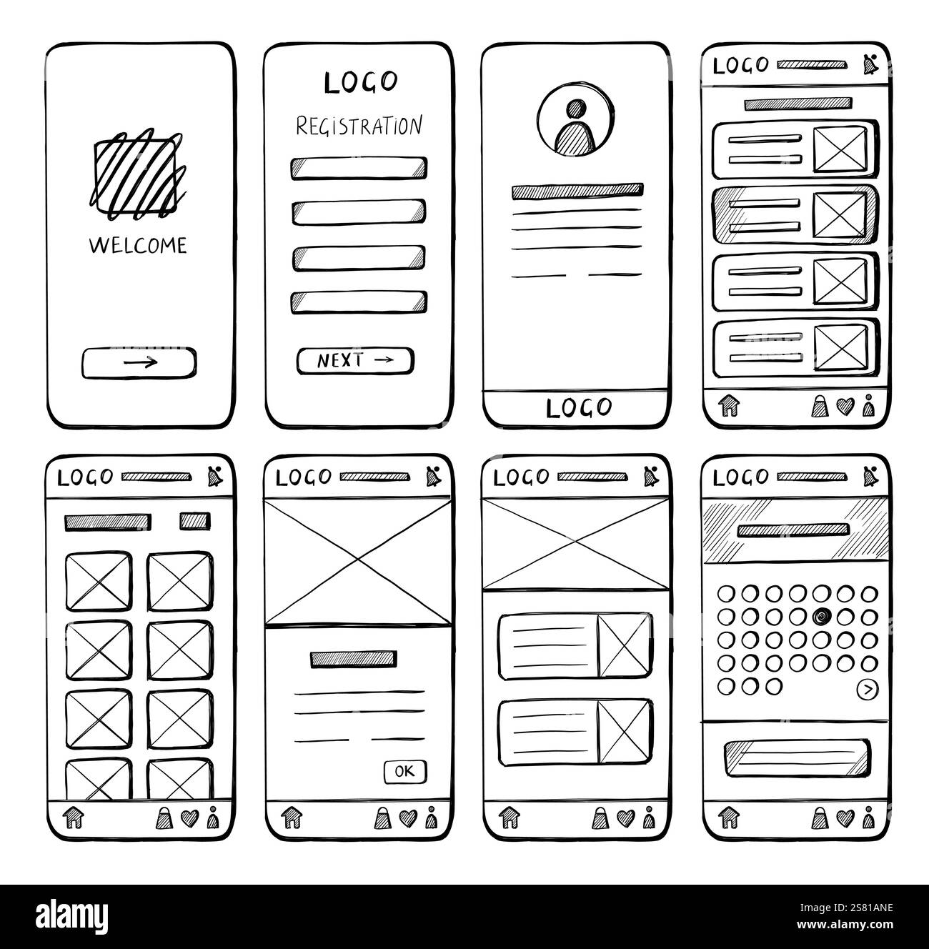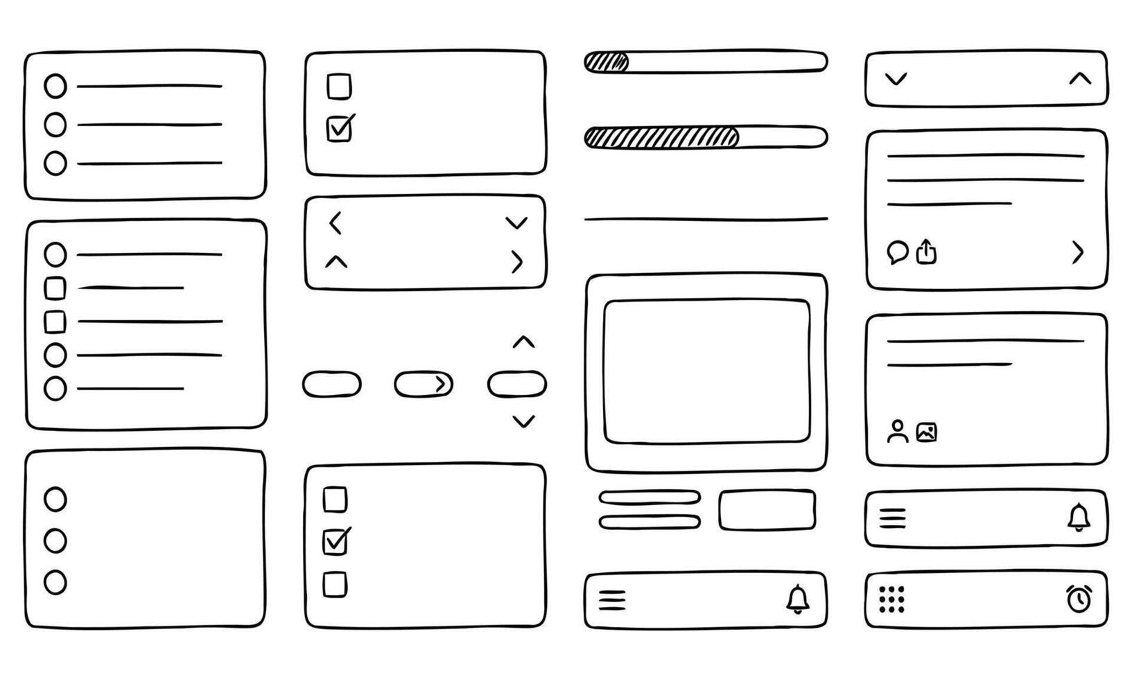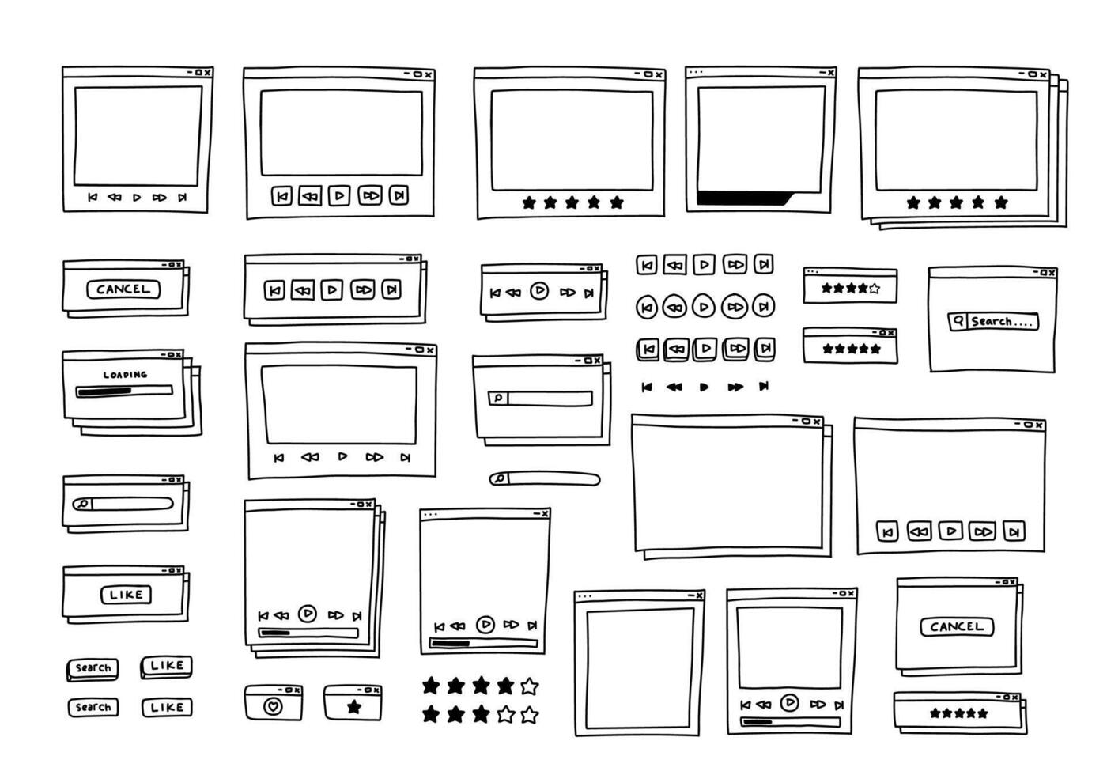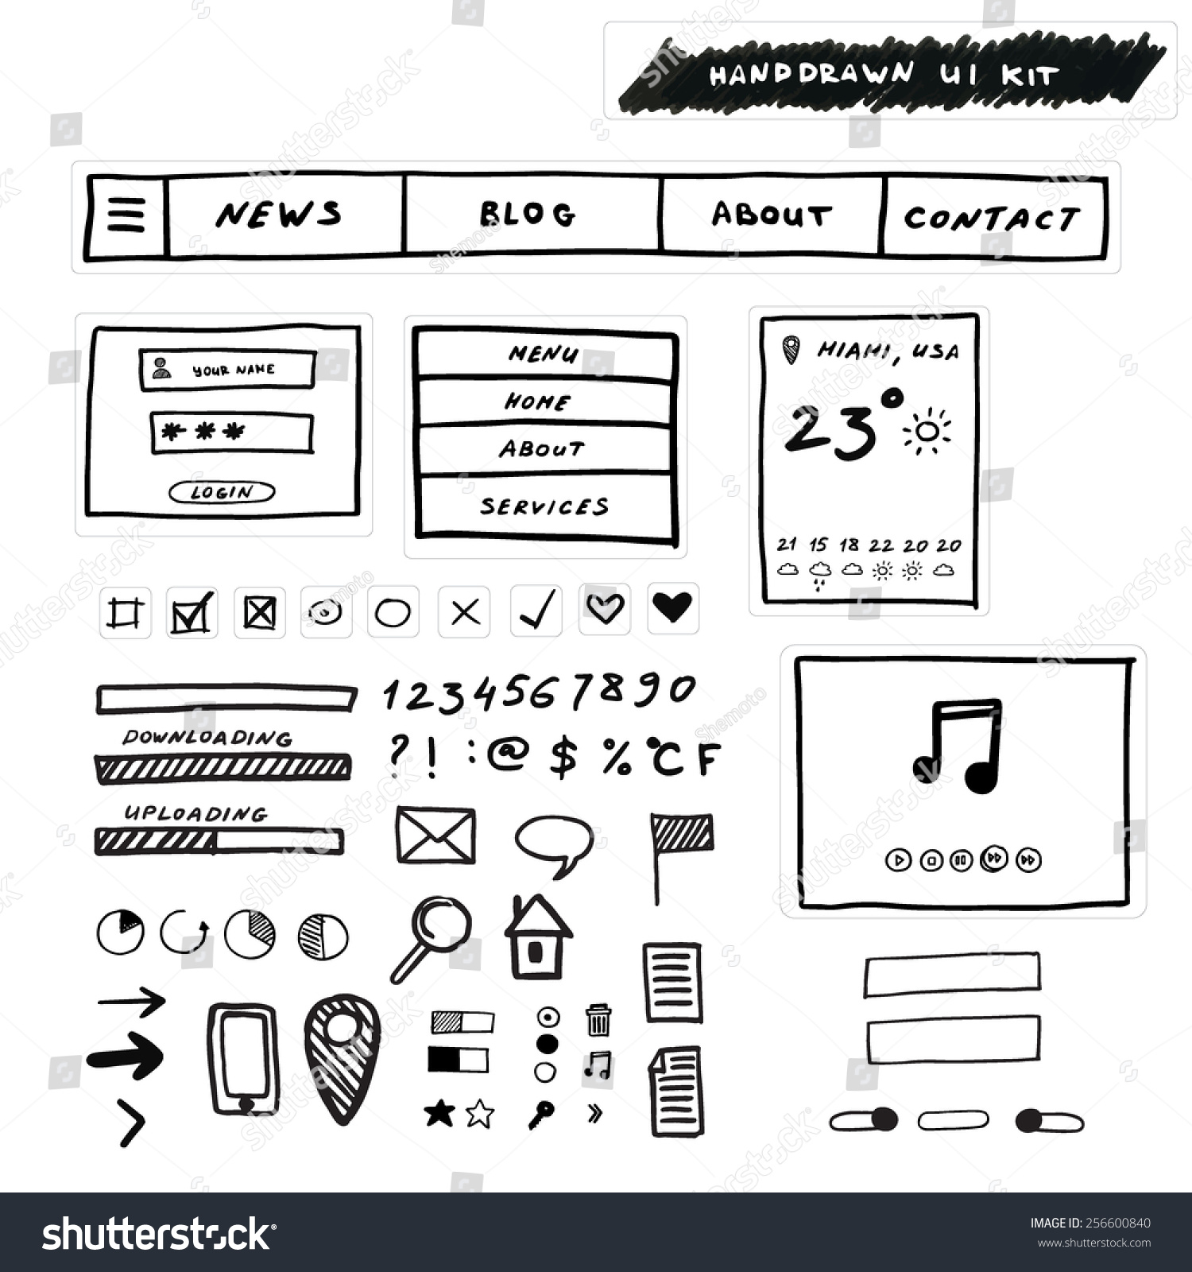

PPR:
These four are one new theme: #20, hand-drawn ink sketch. It would sit in a new family because it needs machinery no other theme uses. Neobrutalism also has thick outlines, but its lines are perfect and filled with flat pastels. Here the line itself is imperfect, and there is no fill color.

The four references
# | Reference | Pen | What it shows
1 | Phone wireframe set | Fine liner | Full screens: welcome, form, profile, card list, image grid, calendar, tab bar
2 | Component sheet | Fine liner, cleanest | Radio and check lists, progress bars, pills, steppers, cards, nav bars
3 | Doodle retro windows | Fine liner, thinner | Windows with a – ▢ × title bar, stacked offset copies, media buttons, star ratings, search, loading
4 | "Hand-drawn UI kit" | Marker, thick | Nav strip, login, menu list, weather card, hatched progress, icons, slanted hand lettering
The fourth image carries a stock-photo watermark and site text. Those are not part of the theme, and the agent should ignore them.

What the look is made of
Layer | What's in the images
Tokens | Two values only: black ink on white paper. Optional single highlighter color, if you want one.
Stroke | Uniform width, round caps, slightly wobbly. Corners are rounded but uneven.
Fill | None. Emphasis comes from diagonal hatching (progress bars, selected cards, input-field edges) or scribble fill.
Depth | A heavier bottom and right edge, or a second offset outline (the stacked windows). No blur.
Placeholders | A box with an X for images; plain bars for text lines.
Type | Handwriting, mostly uppercase for headings and buttons. Fine liner is neat; marker is slanted and chunky.
Icons | Doodled, with deliberately uneven strokes: house, bag, heart, bell, magnifier, envelope.
Parts | Radio and checkbox lists (hand-drawn tick), pill button, chevron stepper, hatched progress, tab bar, star rating, calendar dots, window chrome, card with text lines.

What makes it work
- The wobble is the identity. It should sit on the strokes only. If it distorts the text, the UI stops being readable.
- Hatching replaces color. Selected, active and filled all use the same diagonal hatch at different densities.
- Consistency of line weight. One stroke width per theme. Mixing widths reads as clip-art.
- Restraint. Monochrome is the style. Color pastels would turn it into neobrutalism.

What it adds to the contract
Addition | Notes
--wobble, --wobble-freq, --wobble-seed | Strength, scale and variation of the stroke displacement
--stroke-width, --stroke-color | Neon Light-Grid already has --stroke-width; reuse it
--hatch-pattern, --scribble-fill | Presets for light, medium and dense hatching
--font-hand plus a fallback stack | Handwriting is not safe across platforms
placeholder part | X-box image slot
skeleton text bars | For loading states, not for real text
stack ornament | Offset duplicate outlines for stacked windows
Hand-drawn icon sprite | Fits the existing swappable icon slot

Two real risks for the contract
- The security rule needs an exception. The wobble comes from an SVG filter (feTurbulence plus feDisplacementMap), and CSS applies it with filter: url(#wobble). The current rule allows url() only for data:. The loader needs to allow same-document fragment references to filters declared in the theme's own sprite. Nothing external.
- The font problem. External fonts are forbidden, so handwriting has to come from a system stack, which differs per platform, or from an embedded data-URI font, which adds size. Handwriting fonts also rarely cover non-Latin scripts, so the fallback rule from the accessibility axis applies here first.

Decisions for the planning round
- Pen: fine liner only, or ship fine liner and marker as two pen variants (same structure, different weight and lettering)?
- Color: strict black and white, or one optional highlighter color?
- Consistency: should every button look identical, or vary slightly (three seeds cycled by position)?
- Wireframe mode: are text bars only for loading states, or do you want a real toggle that renders a whole app as a wireframe?
- Paper: plain white, lined notebook, or grid?
- Font delivery: a system handwriting stack, or an embedded font?
- Scope: do the doodle retro windows count as part of this theme, or do you want that as a separate "doodle OS" theme later?
Send more references if you have them, or tell me to start the Q&A and I'll walk through those one by one. I haven't added this to the Atlas yet, so it will go in with the next update.

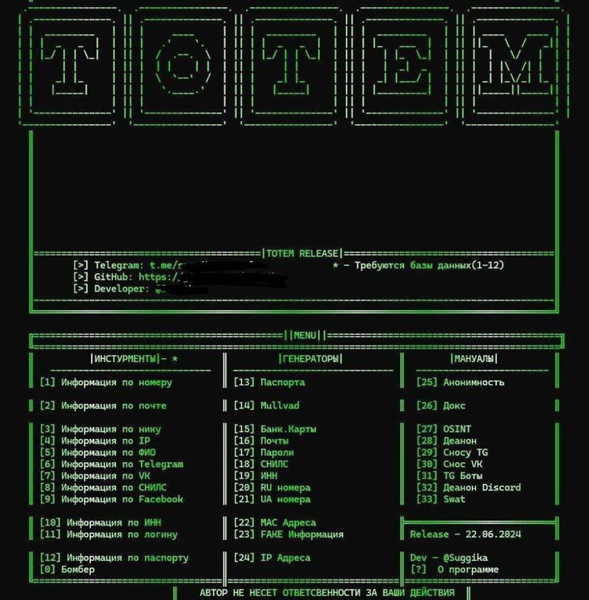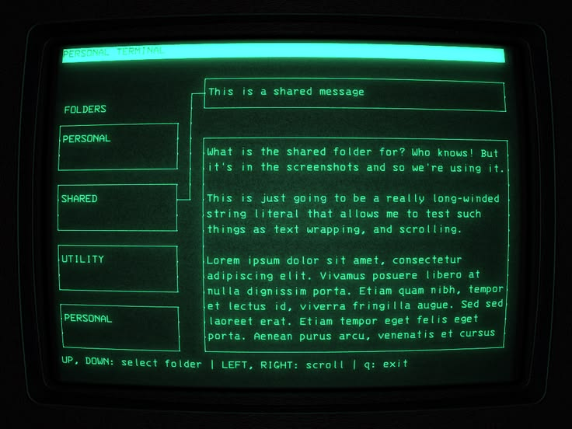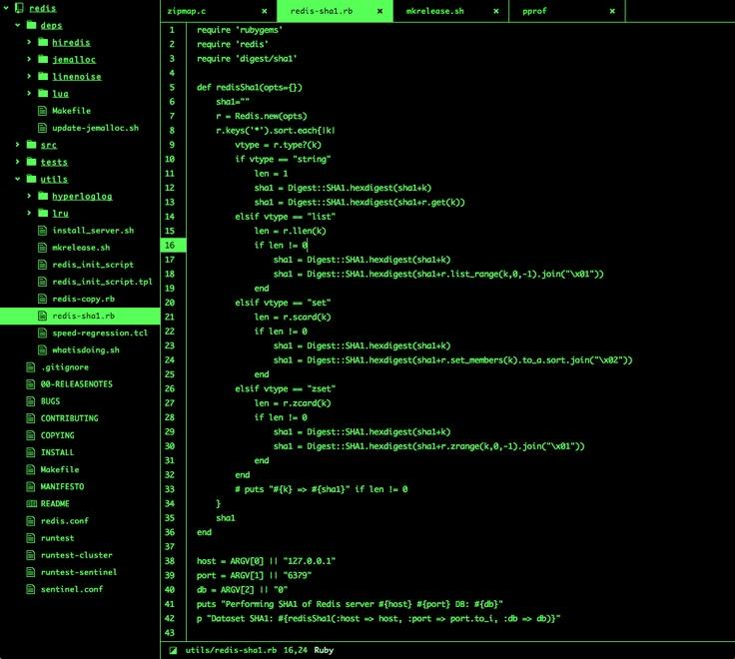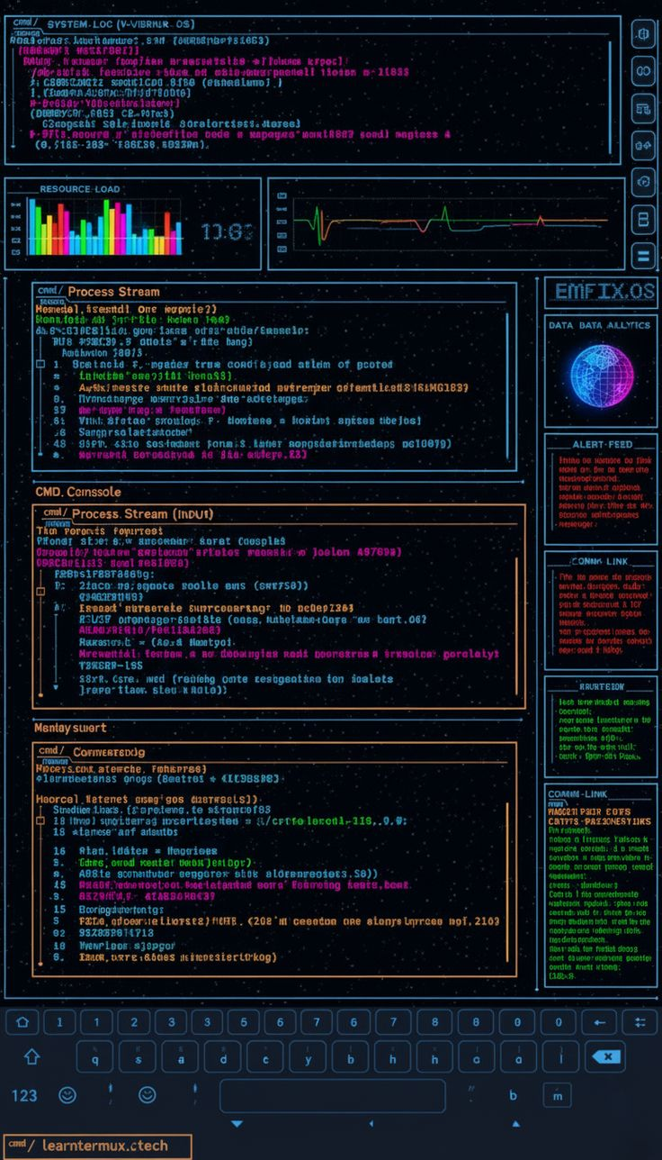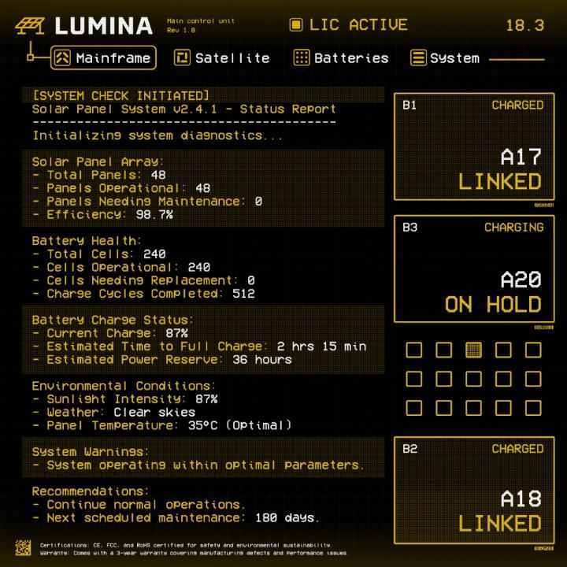

PPR:

These five are one new theme: #21, Terminal / TUI. You wanted references that disagree, and these do, which settled the biggest open question from the plan.

The five references
# | Reference | What it is
1 | Green ASCII menu | True character-grid UI. Frames drawn with box-drawing characters, a banner in block letters, a three-column numbered menu ([1]), a label embedded in a rule (=====|MENU|=====)
2 | Green CRT with bezel | Thin box outlines with tick marks, a cyan inverted header bar, a connector line from the selected folder to its message, a key-hint footer, glow and scanlines
3 | Code editor | Tree with folder glyphs, editor tabs with ×, line-number gutter, bright inverted selected row, status line at the bottom. Terminal look in a GUI layout
4 | Mobile terminal HUD | Multi-hue panels with colors by role (blue info, orange input, red alert, green status), a resource chart, an on-screen keyboard. It looks AI-generated, so the text is garbled; ignore the text and the site name
5 | Amber instrument panel | Amber on black with dotted-grid panel fills, icon tabs in boxes, big numeric cards, a checkbox grid with one cell dithered, boxed status chips

The finding: two kinds of terminal
- Cell-true (1, partly 2): sizes are whole characters, and borders are characters.
- Grid-flavored (3, 4, 5): monospace type and a terminal palette, but boxes are drawn like normal UI.
So the contract gets a switch: --grid: cell | loose. Loose is the default and works for every app. Cell mode adds --cell-w and --cell-h, and sizes and spacing snap to whole cells.

Palettes (one structure, three looks)
Palette | Colors | From
Green phosphor | Bright green, dim green, black | 1, 2, 3
Amber | Amber, dim amber, black | 5
ANSI multi-hue | 16 ANSI slots, with role colors per panel | 4

What it adds to the contract
Addition | Notes
--cell-w, --cell-h, --grid | Cell mode snaps sizes and spacing to whole cells
--border-style | single, double, rounded, heavy, ASCII (= rules), tick-marked
--ansi-0 to --ansi-15, --palette-mode: ansi16 | Joins the existing mono and fixed palette modes
--cursor | Block, underline or bar, optional blink
--select-bg / --select-fg | Reused: the inverted row is the selected state everywhere
--grid-fill | Dotted panel texture (ref 5)
ruletitle part | A panel title embedded in its border or rule
keyhints | Footer bar, plus [n] hotkey labels on controls
connector | Line linking a selected item to its detail panel
gutter | Line numbers for code and long lists
tabstrip variant | Tabs with a close ×, on a rule
numbercard | Big readout with a label, a variant of readout
checkgrid | Grid of boxes with per-cell states
Role-colored panels | Info, input, alert, status, used by the ANSI palette

Reuse before adding
- screen, --crt-level, the glow and scanline tokens and the bezel from TVA
- --palette-mode and the dither presets from Game Boy and CGA
- --glow-* from Neon Light-Grid
- readout and datagrid from the earlier themes

Rules for the agent
- Reference 1 is a menu for a tool that looks people up and targets them (phone, ID and passport numbers, de-anonymizing, swatting guides, account takedowns). I'm taking only its visual structure. The agent must write neutral stand-in labels and copy none of its text, banner or links.
- Original ASCII banners only. Draw a new one; don't trace those.
- Ignore the garbled text, the site name and the stock-style captions in 4 and 5.
- Script coverage is a hard limit. Cell mode assumes one character per cell, which fails for Bengali, Arabic and Devanagari, where letters join and widths vary. Text in those scripts must fall back to loose layout, never be clipped or hidden.
- Monospace type through system stacks or an embedded font.
- Effects follow --crt-level and fall back under reduced motion.

My recommended defaults for the plan
Decision | Recommendation
Grid | Loose by default, cell mode opt-in per app
Borders | CSS and SVG snapped to the cell grid; real glyphs only for title rules
Type | Monospace everywhere inside the theme
Palettes | Green, amber and an ANSI-16 variant
Key hints | Optional parts, never required
Tests | Pages A and B plus a cell-grid check (all box sizes are multiples of the cell)
Difficulty | Medium to look right, hard for the contract
That answers five of the six questions I listed in the Atlas. The open one is whether you want a real cell mode at all or only the loose, terminal-flavored look. Say "defaults" to accept the table, or tell me what to change. I'll add this, plus hand-drawn, to the Atlas at the next update.

EXTRAS:

[-] Art Nouveau UI
[-] Steampunk UI
[-] Nothing OS
[-] symbianOs
[-] windows 8 metro/windows phone
[-] XP.css
[-] 7.css
[-] 98.css
[-] Webamp
[-] SerenityOS
[-] Dark Aero
[-] Y2K futurism
[-] retro OS UI
[-] weirdcore
[-] dreamcore
[-] winamp glass amp4
[-] 16-bit UI
[-] XMB menu
[-] Minecraft GUI
[-] PS2 menu
[-] glitchcore 95
[-] Matrix code aesthetic
[-] retro MP3 player
[-] VCR on-screen display
[-] ASCII art interface
[-] Frutiger Eco
[-] Hand-drawn UI
[-] Data-dense utilitarian interface
[-] Real-wood skeuomorphism
[-] Packard Bell Navigator
[-] Terminal/ CLI UI design Style
[-] real wood skeuomorphism ui design style
[-] FUI/ HUD UI design style
[-] Halftone/ Comic Book UI style

Your list is 34 lines, but only 33 are distinct, because real-wood skeuomorphism appears twice. Most of it already maps to what we have.

Already covered (13): no new theme needed
Your item | Covered by
98.css | #6 Windows 98
XP.css | #7 Windows XP Luna
Webamp | #4 Winamp panel
Retro OS UI | The Bevel OS family (#1, #6, #7) plus Pixel (#5)
Glitchcore 95 | #12 CGA Neon Desktop (your reference image is in it)
16-bit UI | #14 Game UI, #18 Console OS, #5 Pixel
Terminal / CLI, ASCII art interface | #21 Terminal / TUI
Matrix code aesthetic | #21 as a green palette with a falling-code background ornament
FUI / HUD | #2 Coral HUD, #15 Neon Light-Grid
Hand-drawn UI | #20 Hand-drawn
Data-dense utilitarian | #10 Data utility
Real-wood skeuomorphism (duplicate) | Merged into one entry below

Variants of existing themes (7): cheap, a palette or small extension
Your item | Variant of | What changes
Dark Aero | #17 Aero glass | Dark glass palette
Frutiger Eco | #13 Gel and #17 | Green and nature palette, leaf and water ornament
7.css | #17 Aero glass | Win7 "basic" and Aero chrome, solid taskbar
SerenityOS | Bevel OS (#6) | Its own gray-blue bevel palette
Winamp glass amp4 | #4 Winamp | Glassy skin variant
Retro MP3 player | #8 and #9 media-metal | Small LCD and click-wheel parts
Y2K futurism | #13 Gel | Chrome, blobs, cyber-plastic palette

Genuinely new (13)
Theme | Effort | What's new
Windows 8 Metro / Windows Phone | Easy | Flat color tiles, huge light type, no chrome
Nothing OS | Easy | Dot-matrix type, monochrome plus one red accent, transparent parts
VCR on-screen display | Easy | Blocky mono text, PLAY ▶ counters, tracking glitch
Halftone / comic book | Easy to medium | Halftone dots, speech bubbles, heavy outlines
Minecraft-style GUI | Easy to medium | Blocky gray bevels, slot grids
Symbian | Medium | Glossy blue menus, softkey bars, list-driven
XMB (PlayStation-style menu) | Medium | Horizontal category bar, vertical item list, flowing wave background
PS2-style menu | Medium | Dark blue space with floating light columns
Dreamcore / weirdcore | Medium | Mostly content (low-res photos, odd text); the theme can only provide frames, fades and pixel filters
Art Nouveau | Hard | Flowing ornament, organic frames
Steampunk | Hard | Brass, gears, dials, rivets
Real wood | Hard | Wood grain and veneer, a material variant of Leather
Packard Bell Navigator | Hard | A house-shaped shell with illustrated rooms
The last four, plus Leather and Mossrune, are the hybrid-texture themes that need small image assets.

Shortcut for the Bevel family
98.css, XP.css and 7.css are existing open-source CSS libraries that already recreate those looks. As far as I know they're MIT-licensed; check that before copying anything. The agent can study them for exact bevel and gradient recipes and rebuild them inside your token and parts contract. That makes four Bevel OS themes (98, XP, 7, SerenityOS) much faster than starting from screenshots.

Brand note
Nothing OS, Symbian, Windows Phone, XMB, PS2, Minecraft, Packard Bell and Windows 7 are brands. As with the rest, the agent reproduces the style only, with no logos, wordmarks or proprietary typefaces (use Segoe-style and dot-matrix substitutes).

How it fits the plan
Status | What
Now | Phase 0 and Round 1 (5 themes)
Next | The four Bevel OS themes, built from the CSS libraries
Parked | The easy and medium new themes, then the variants
Later | The hybrid-texture themes
Want me to add this to the Atlas as a Backlog table with these statuses, and write the Phase 0 and Round 1 brief at the same time?

